Sri Lanka Institute of Information Technology



Assignment 1

MLB_04.01_03

Online Job Portal

Internet & Web Technologies – IT1100

Index :-

1. Personas ------------------------ (4 - 8) pg.
2. User Journeys ------------------- (9 - 13)pg.
3. Wireframes ---------------------- (14 - 32)pg.
4. Individual Contributions ------- (33 - 34) pg.
5. Group Details -------------------- (35) pg.

Persona 1

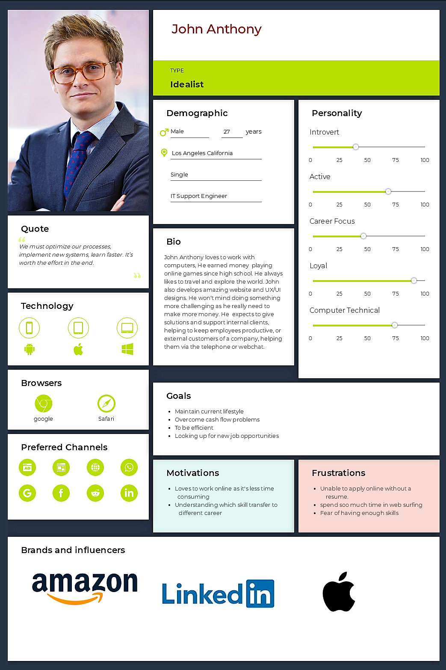

Persona 2

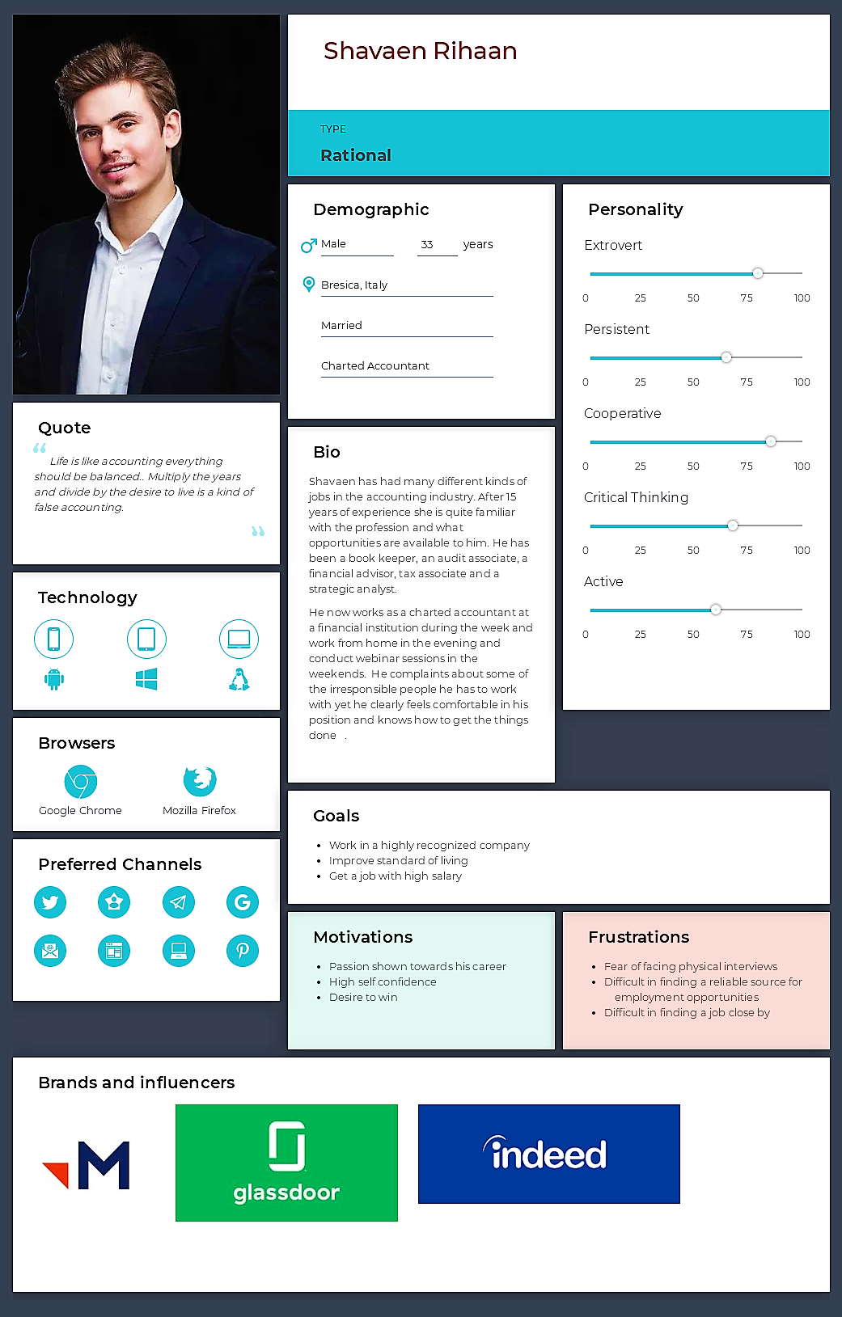

Persona 3

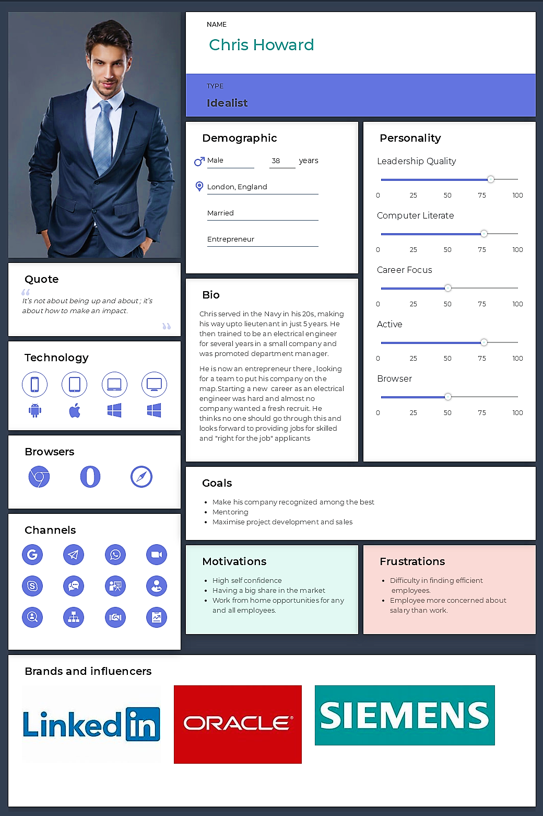

Persona 4

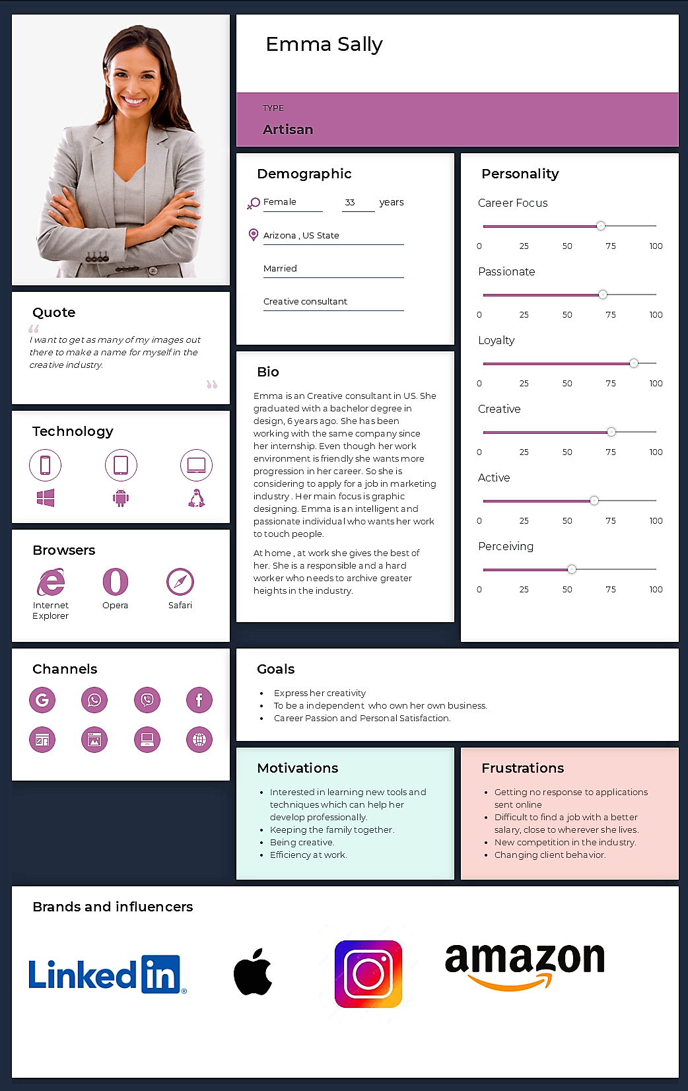

Persona 5

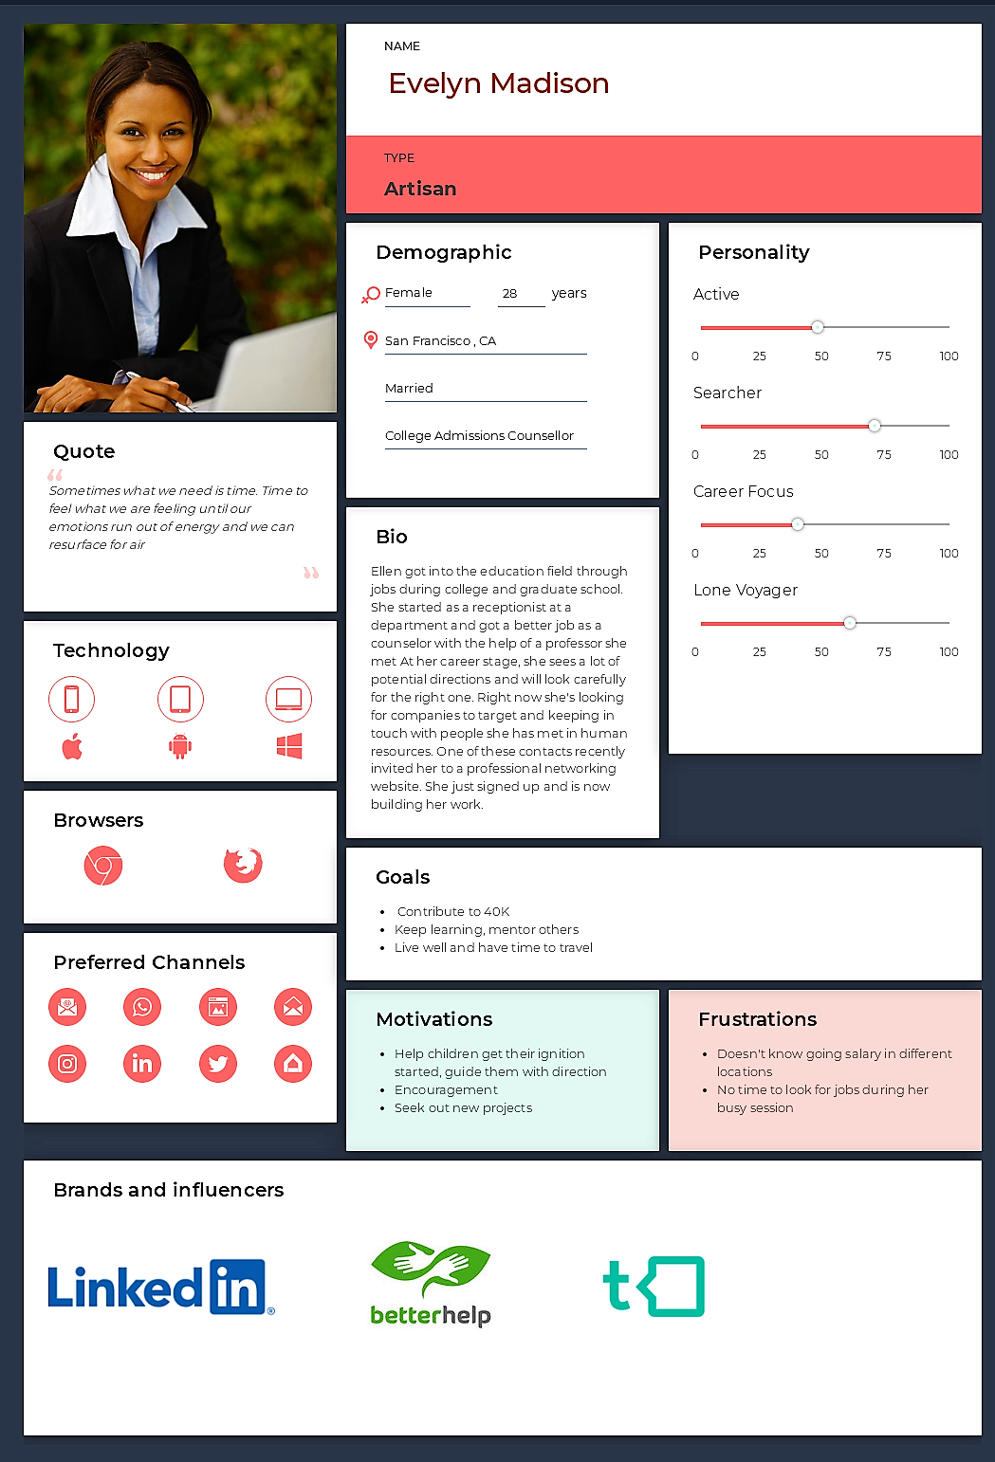

User Journey 1

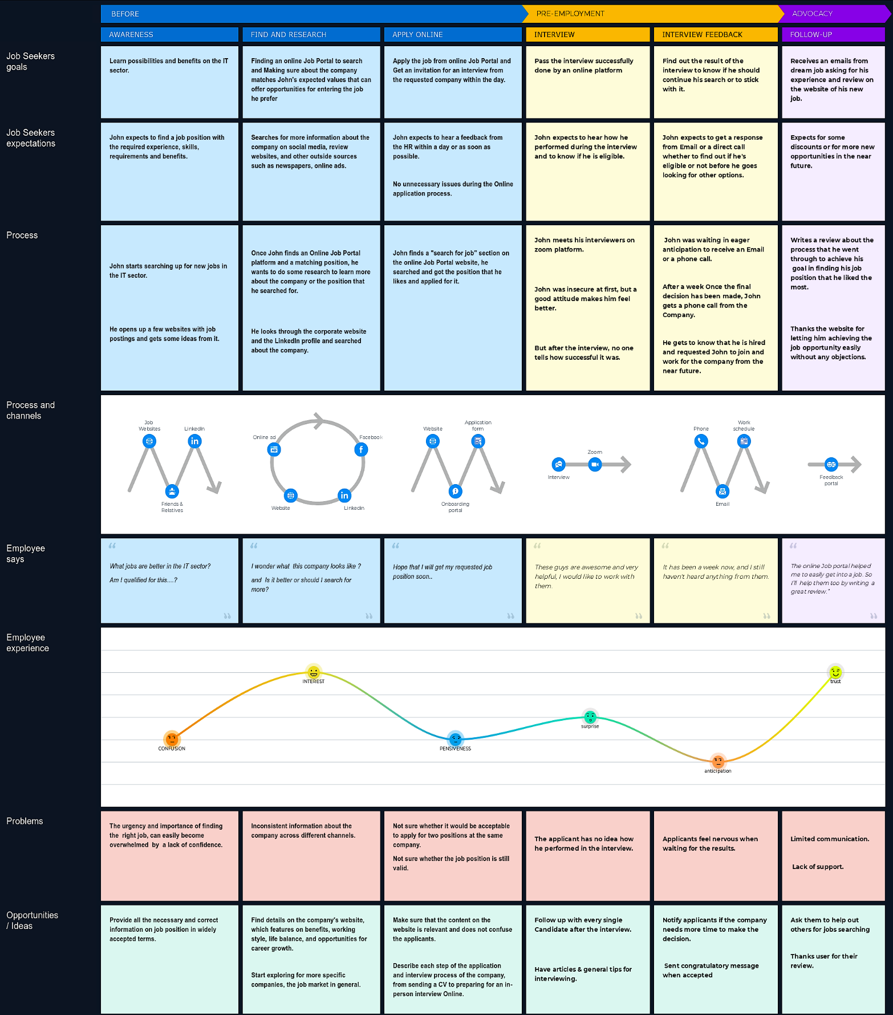

User Journey 2

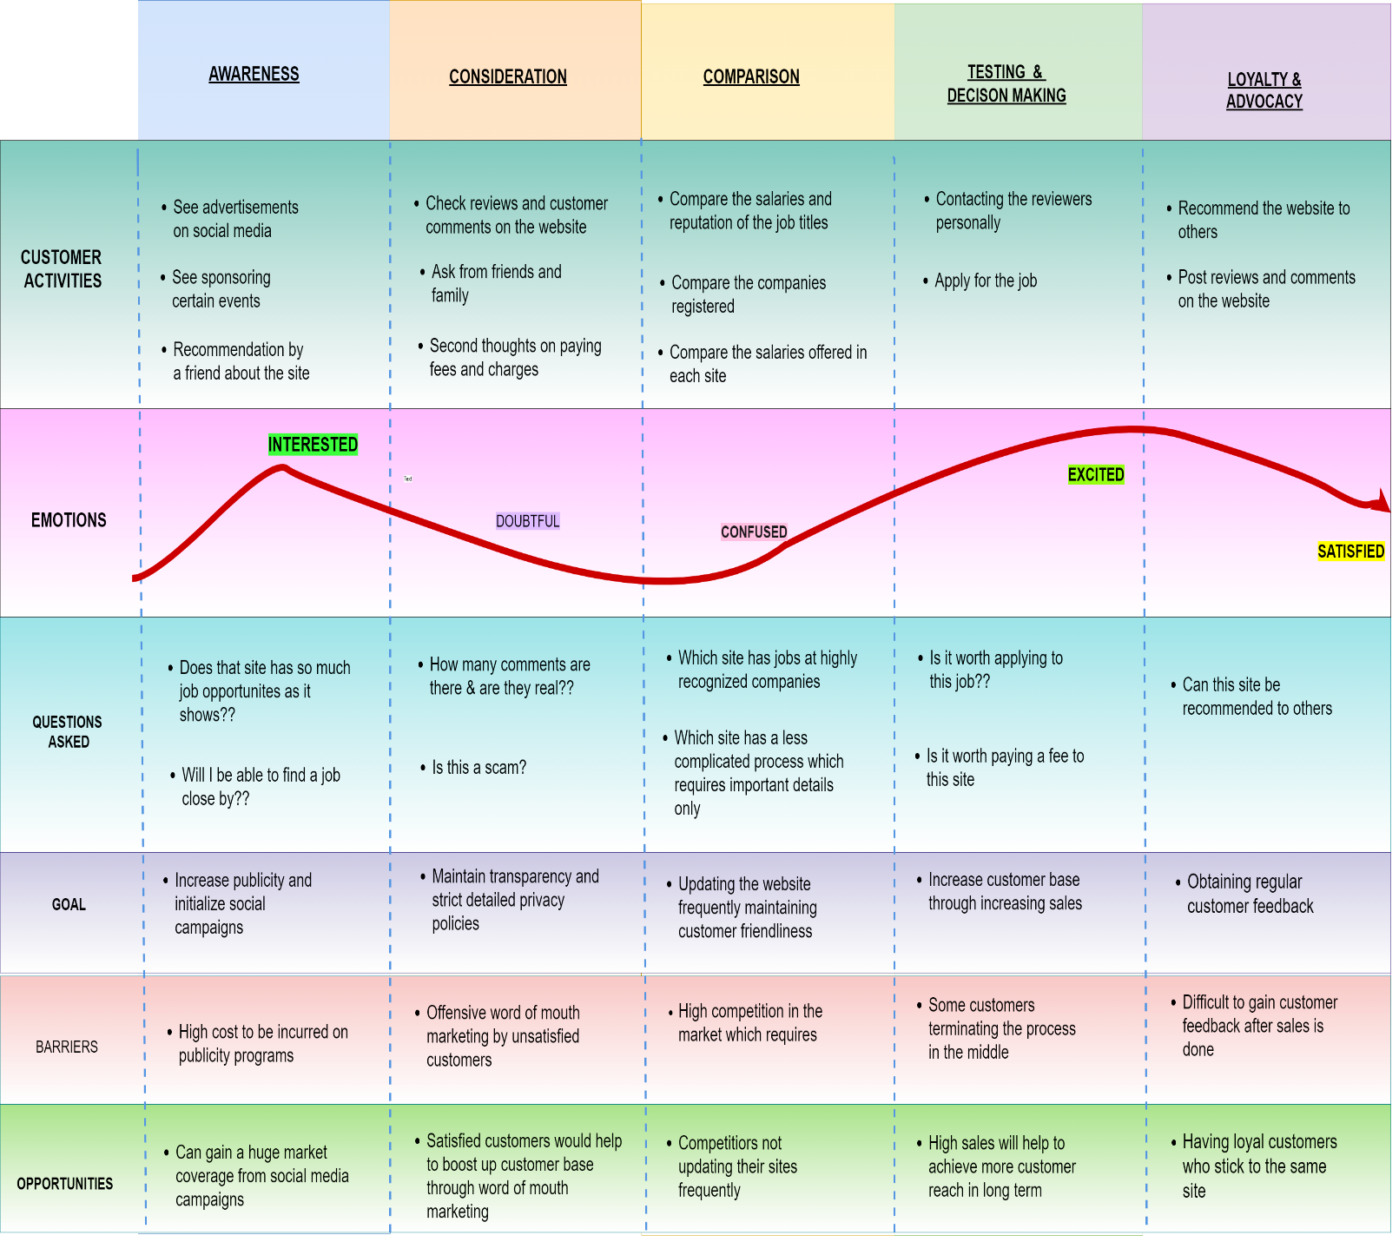

User Journey 3

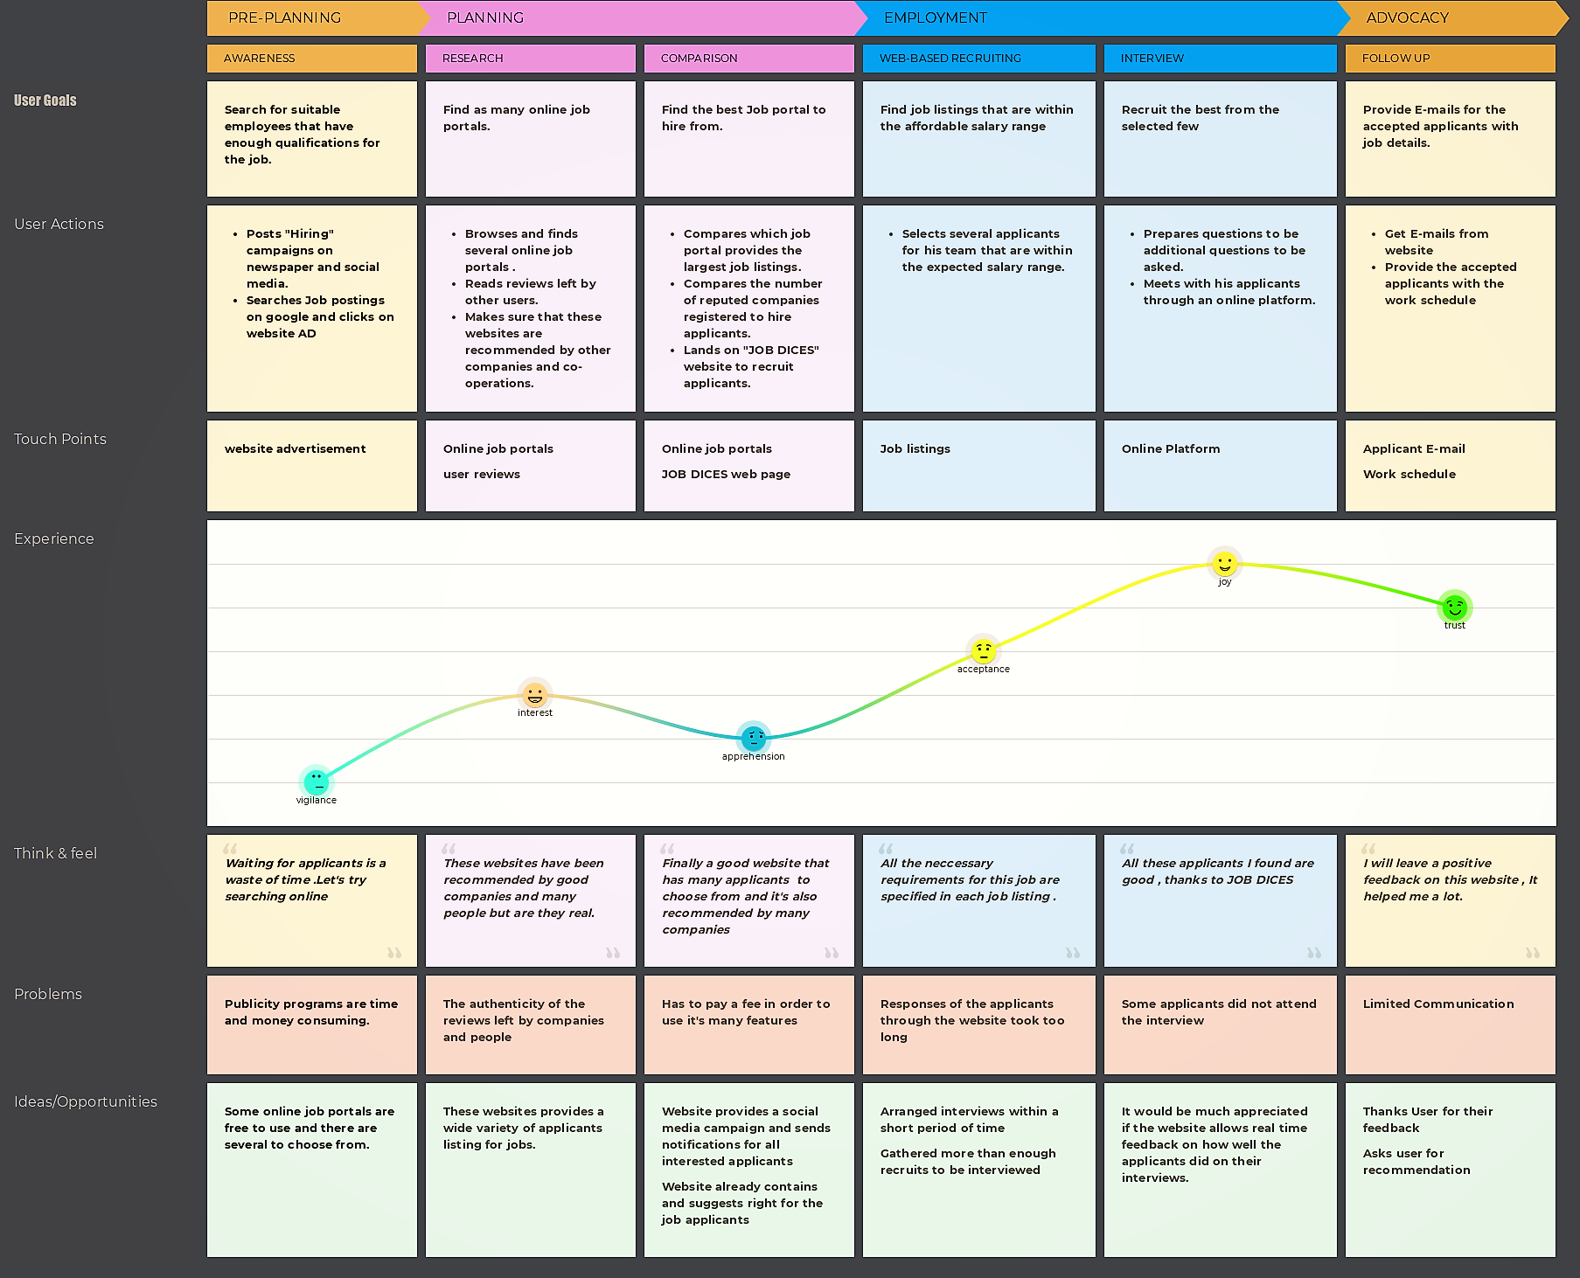

User Journey 4

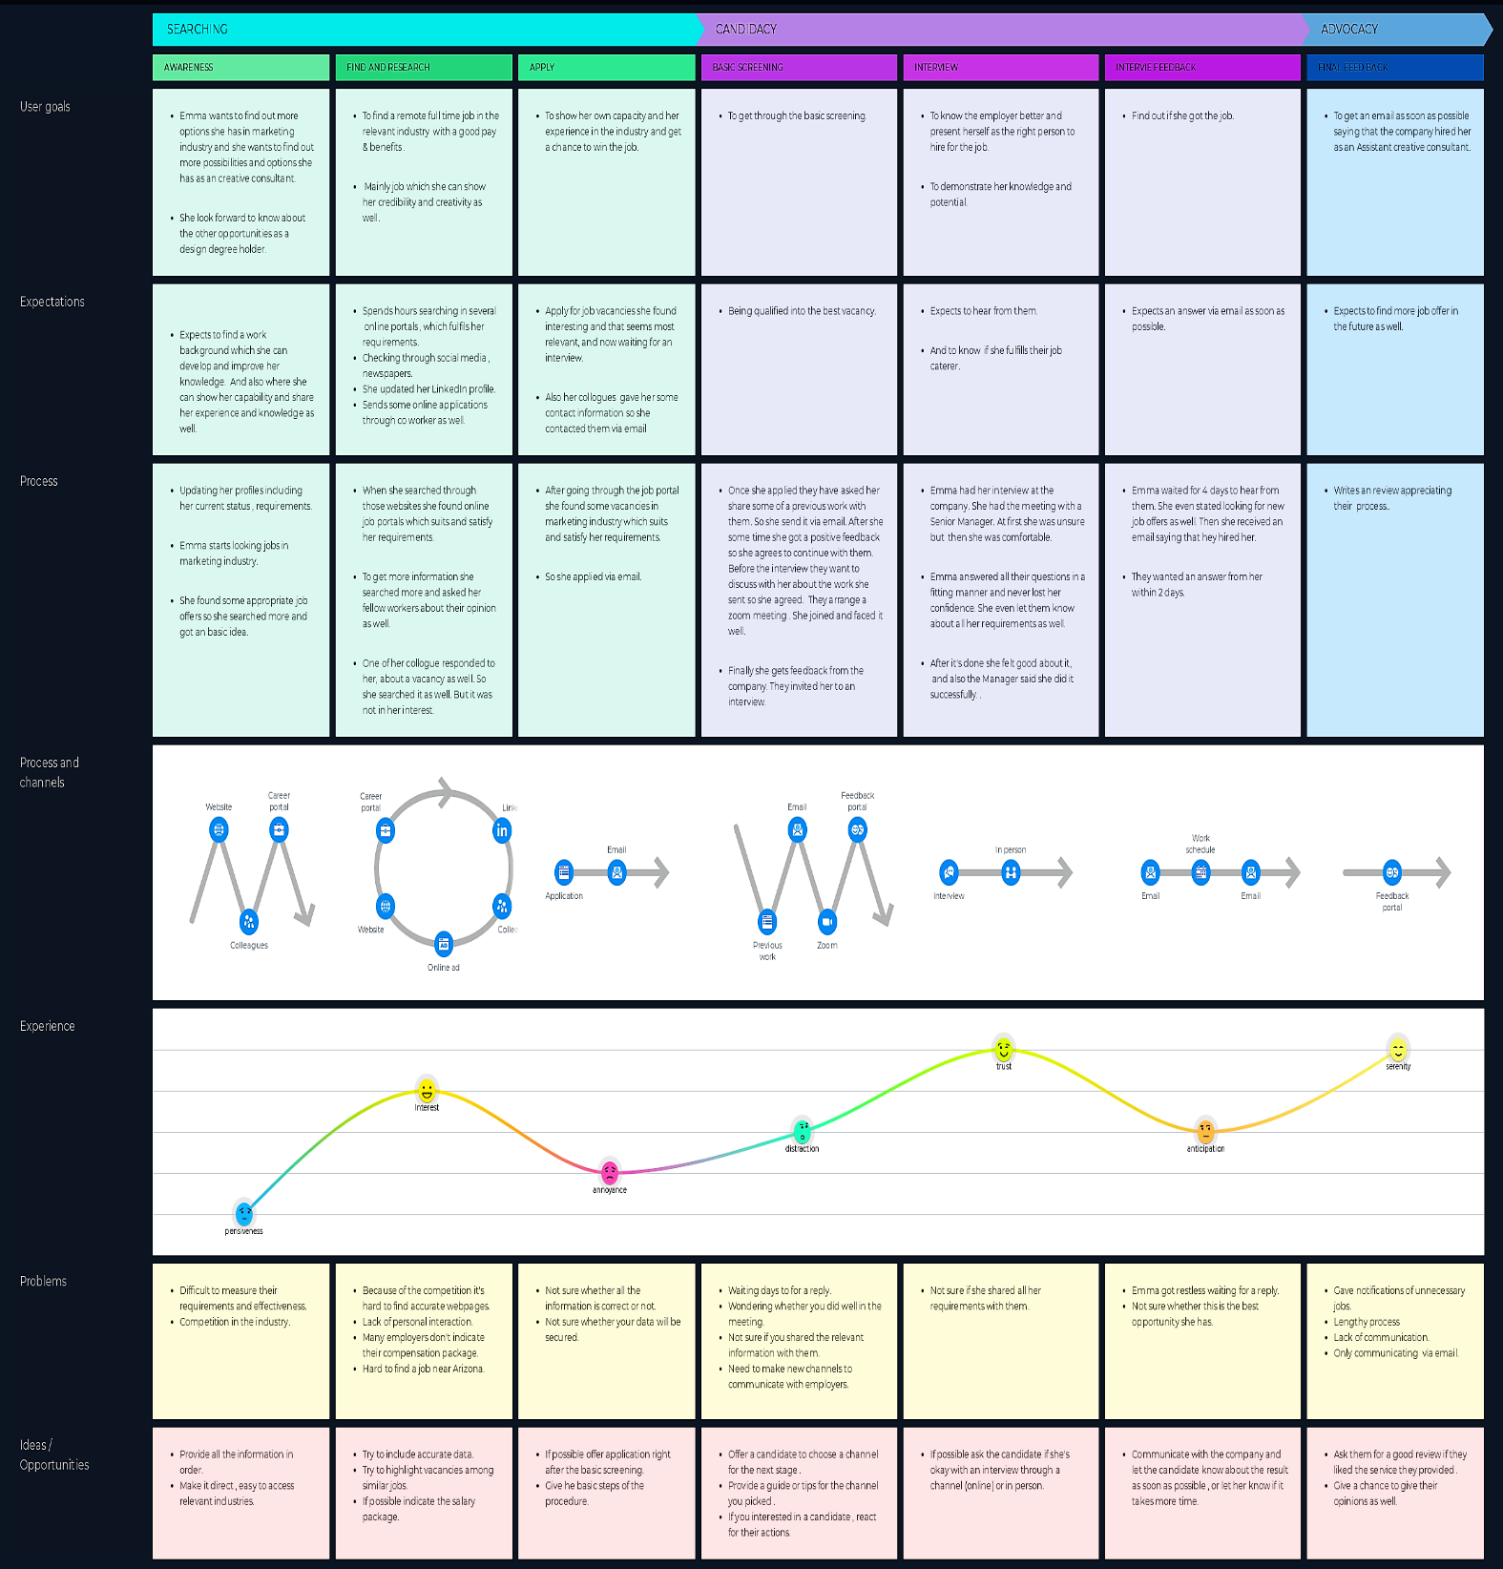

User Journey 5

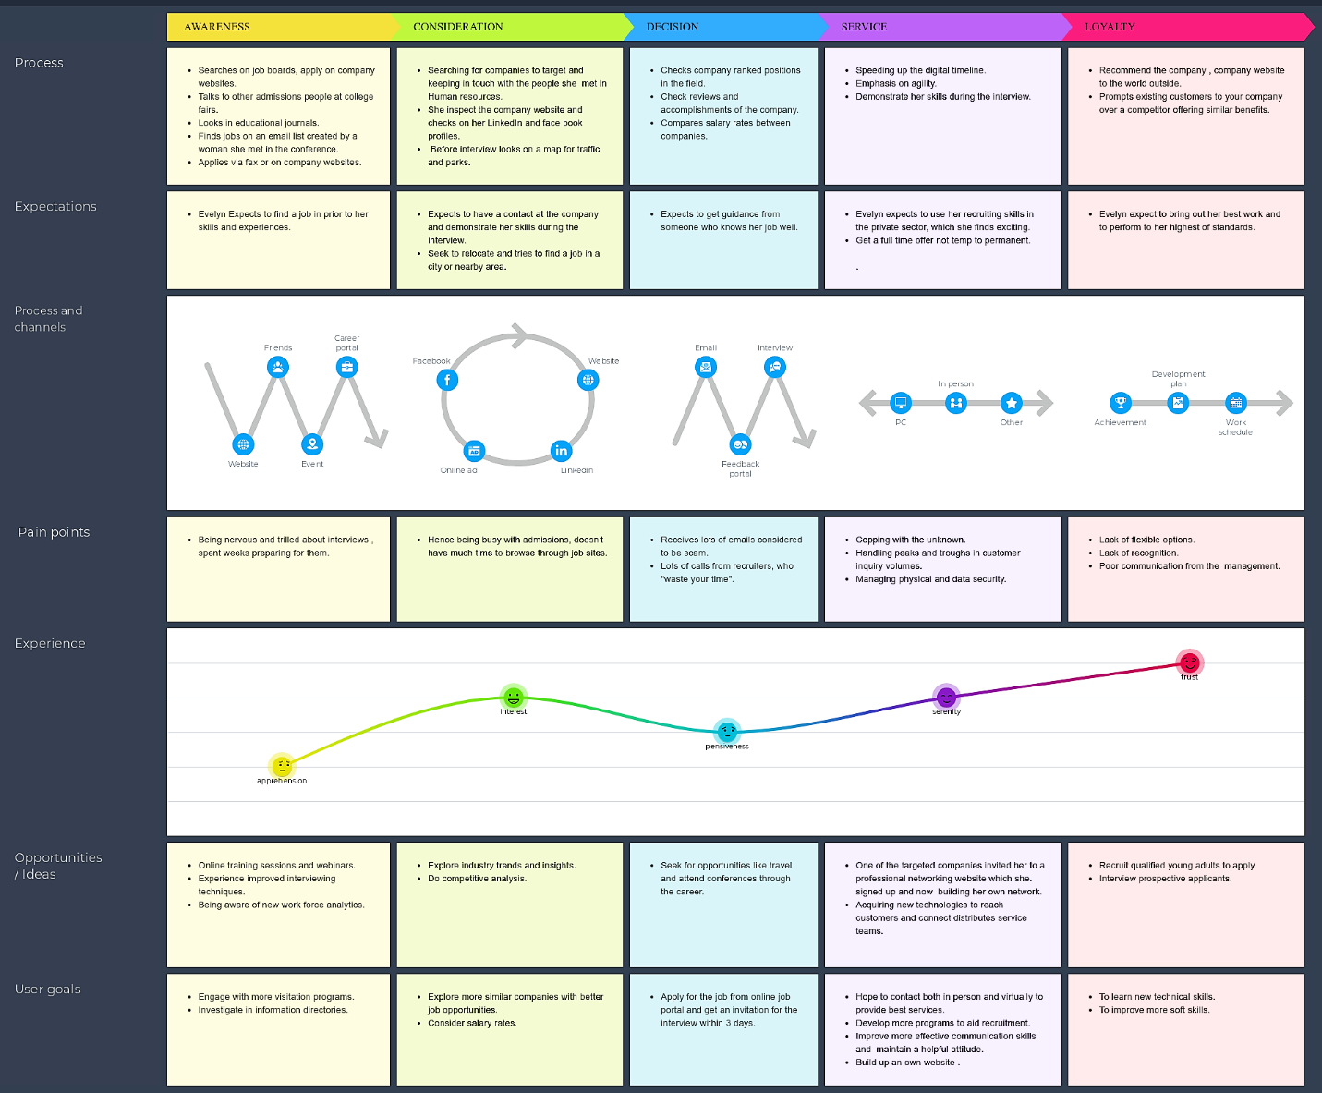

Wireframes

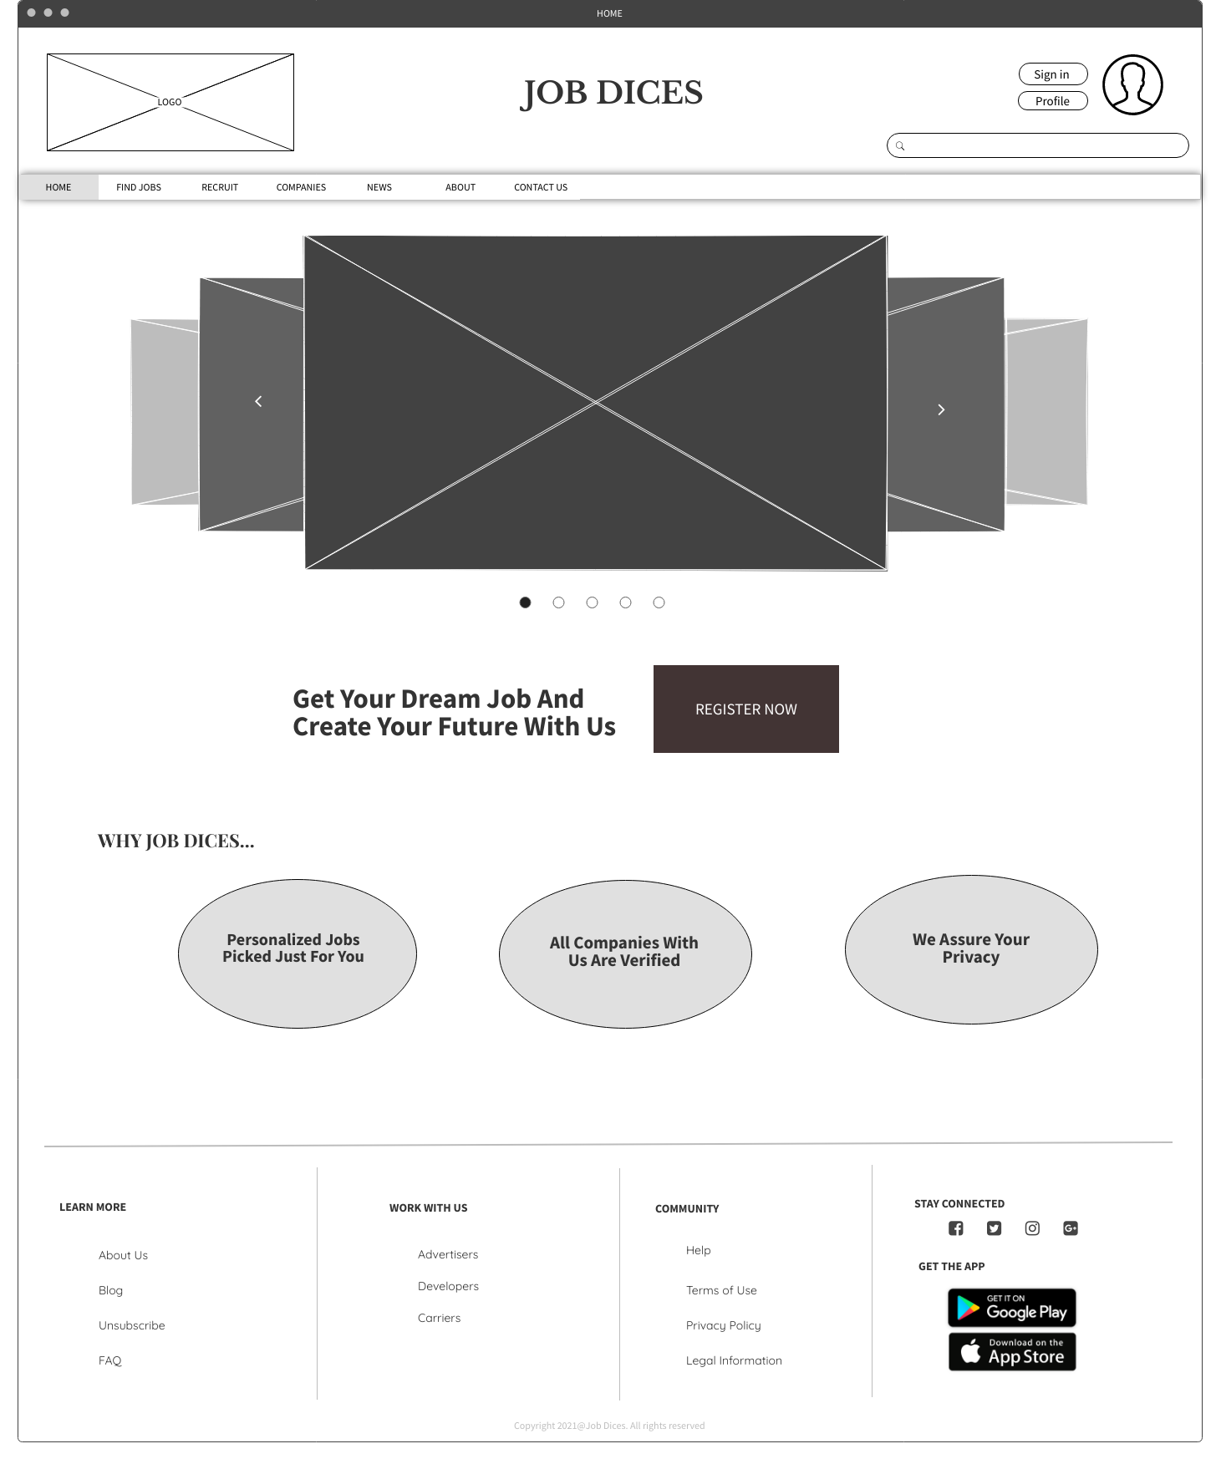

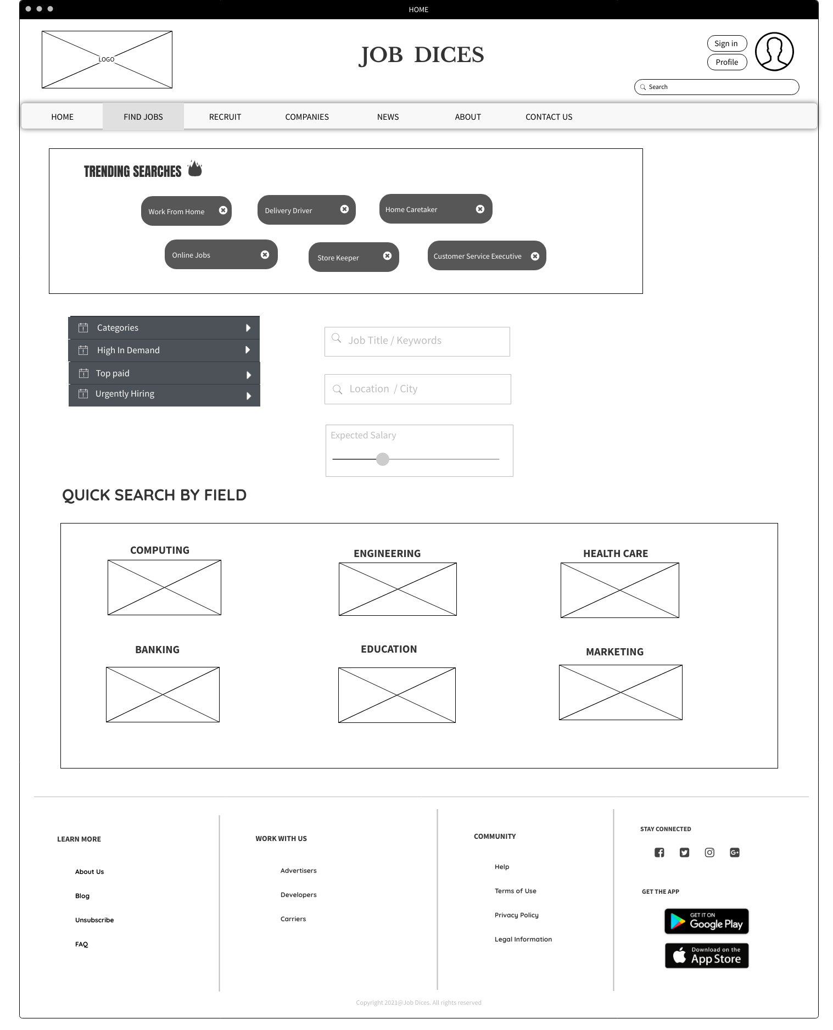

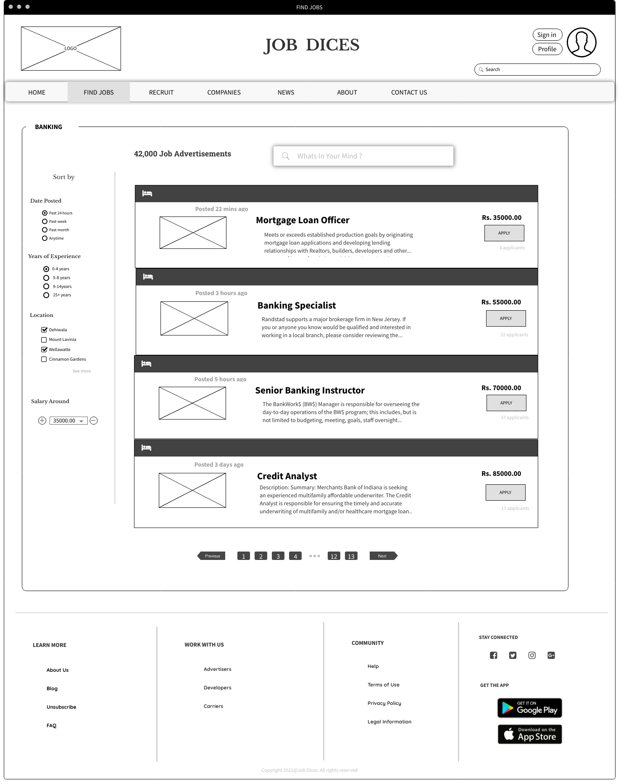

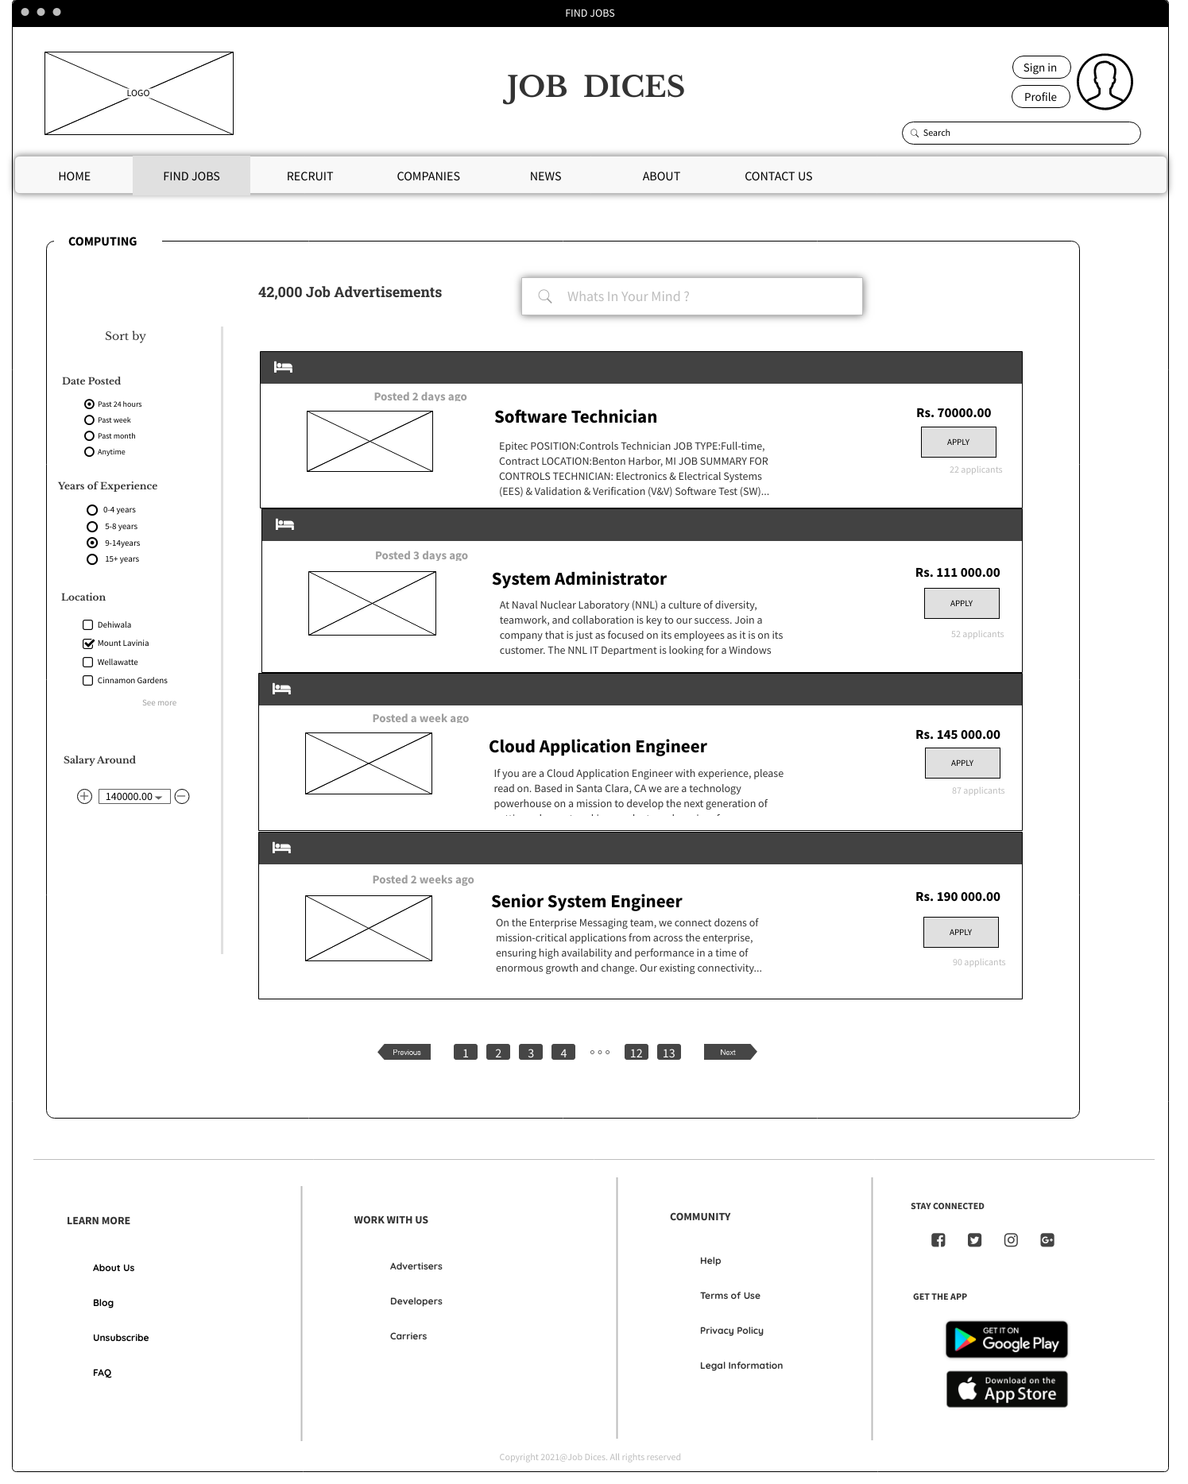

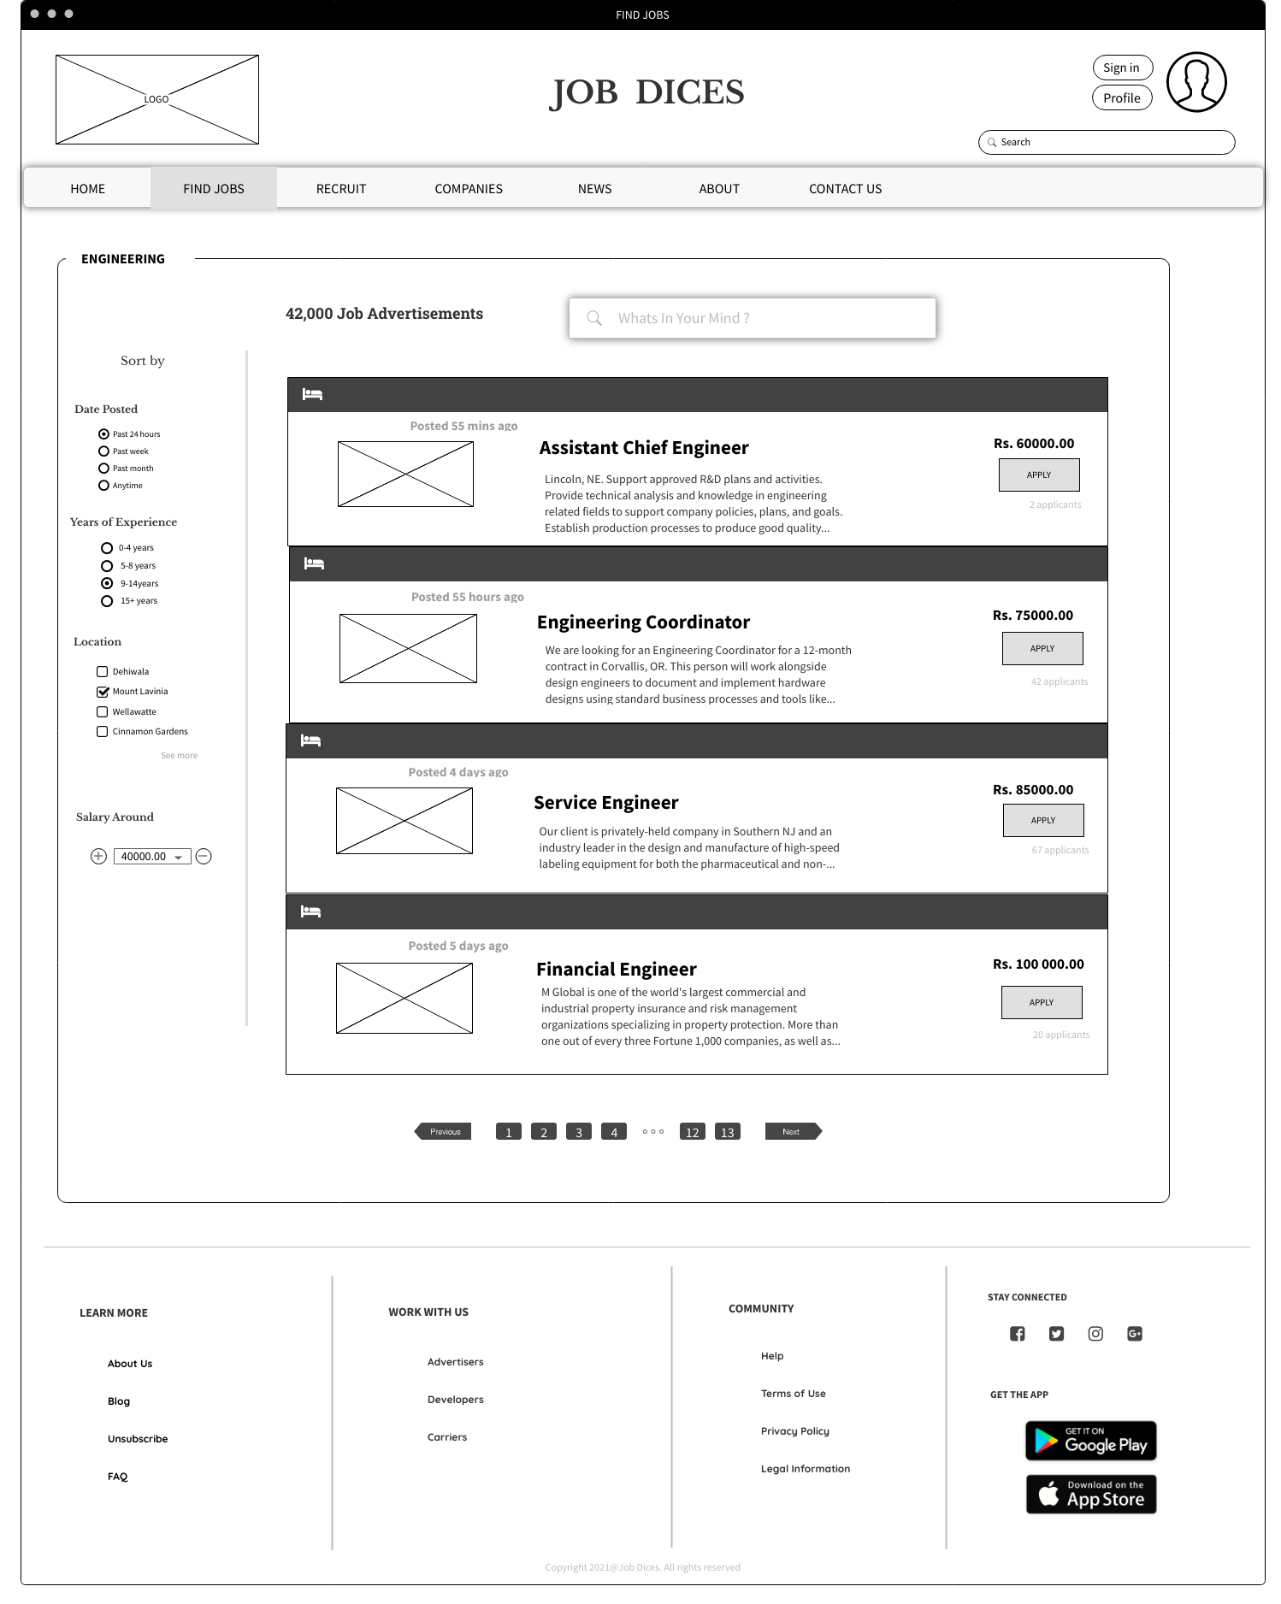

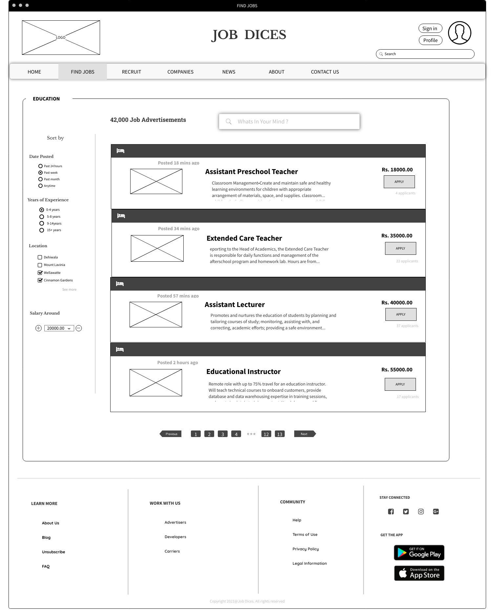

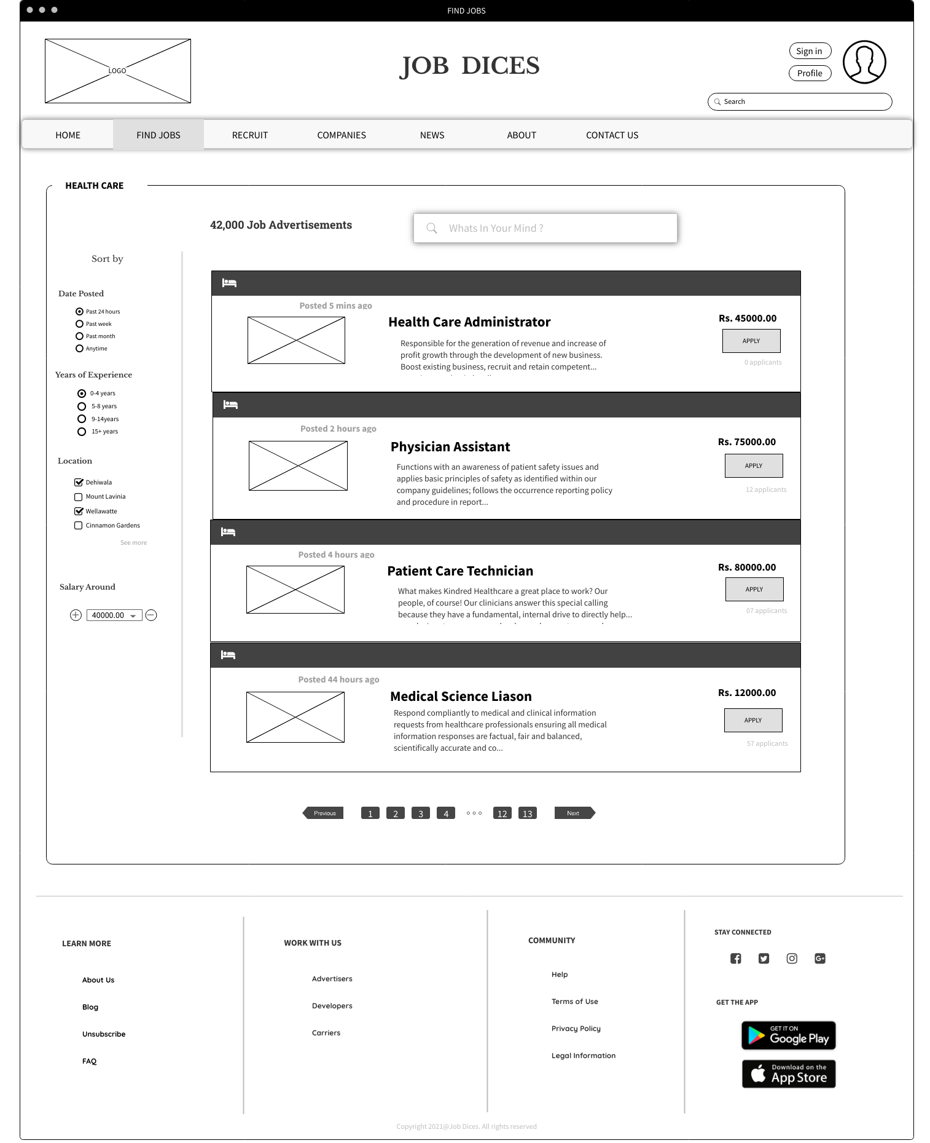

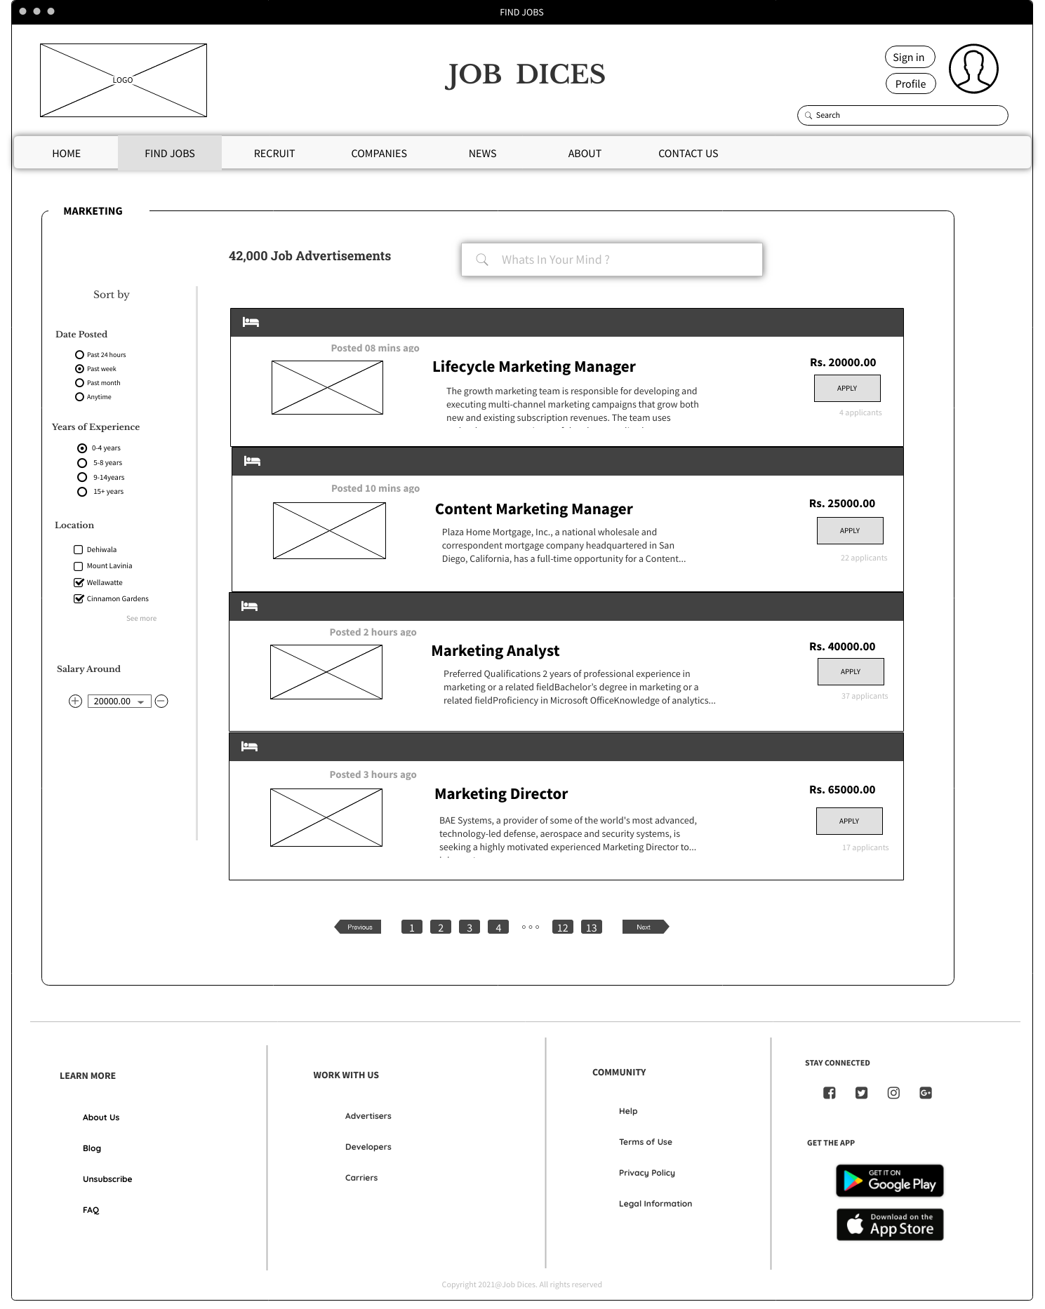

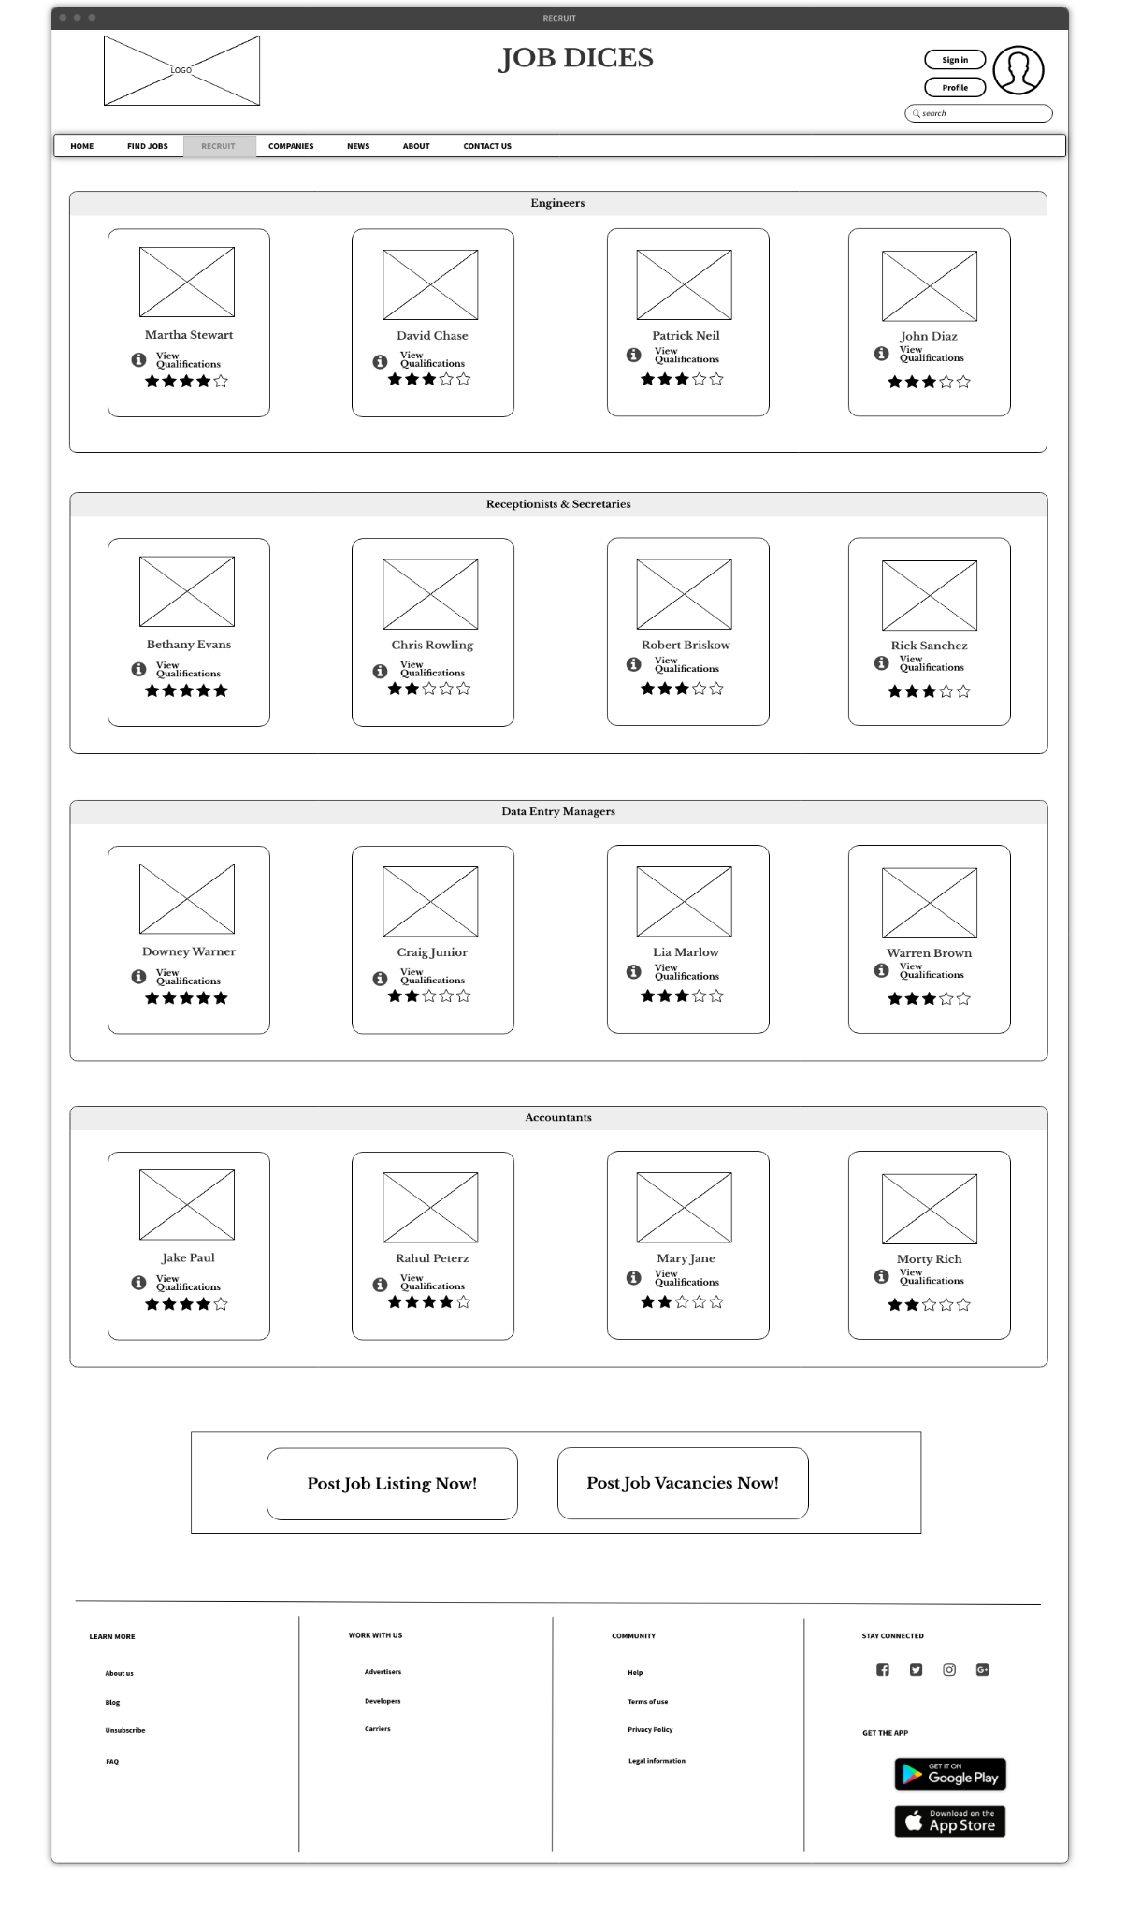

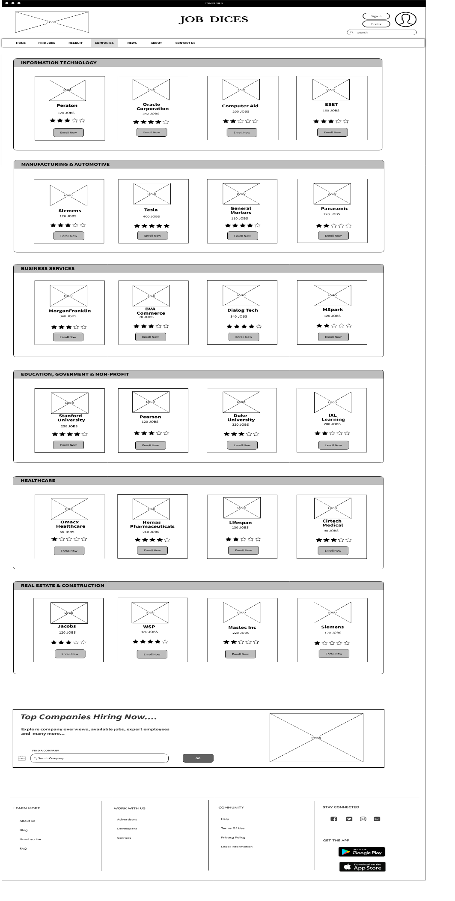

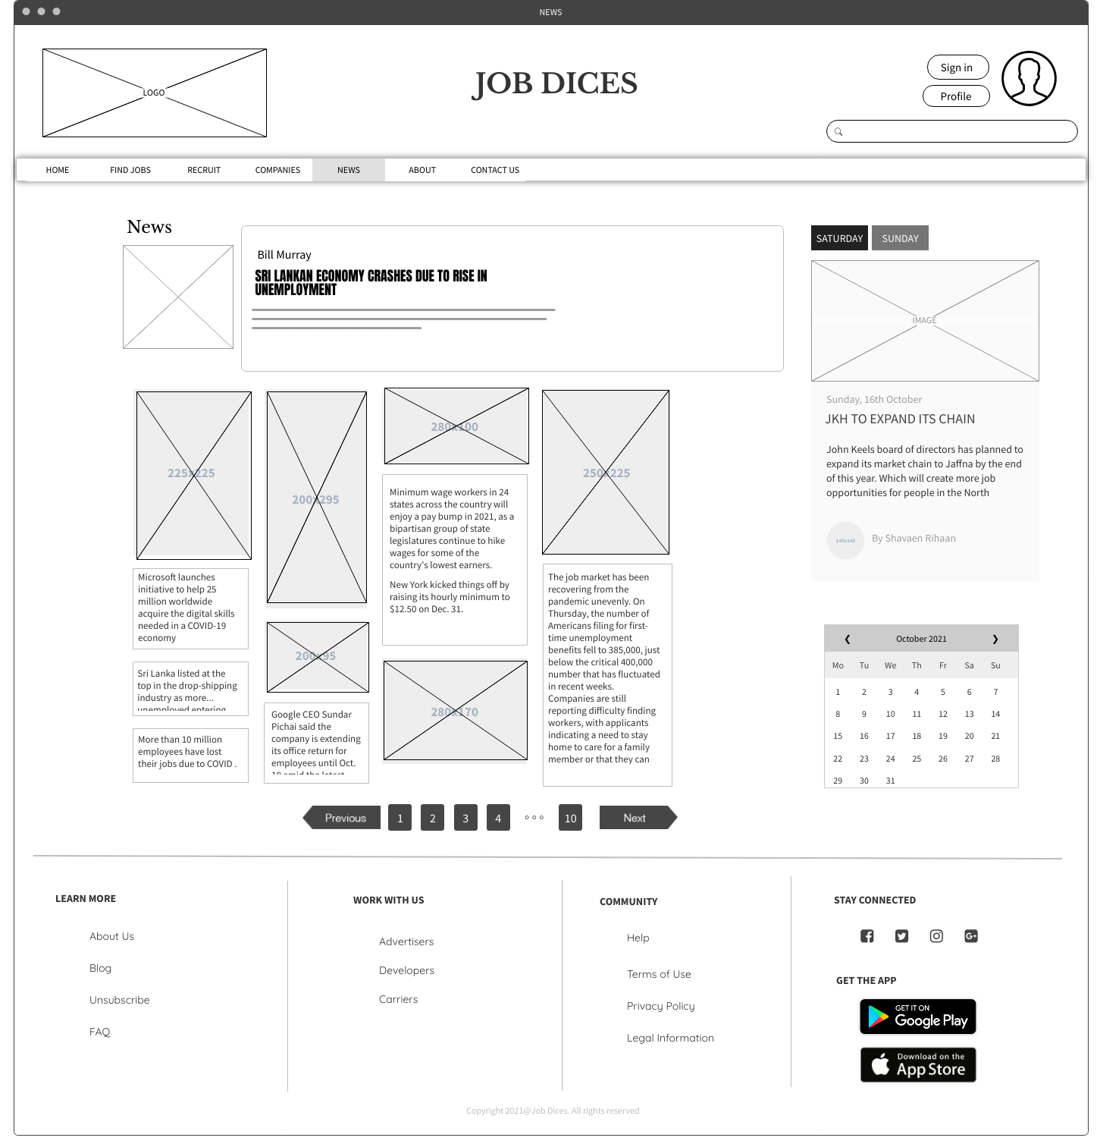

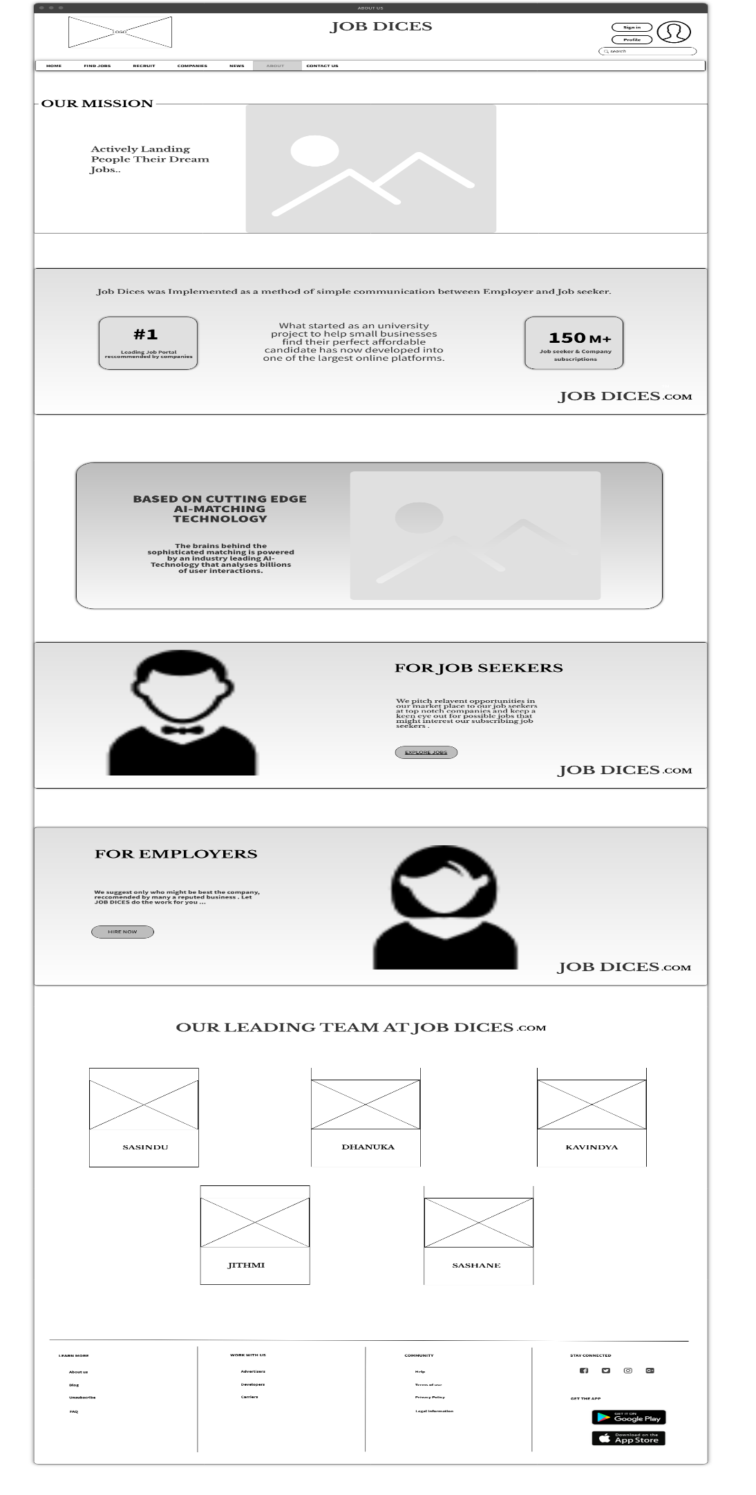

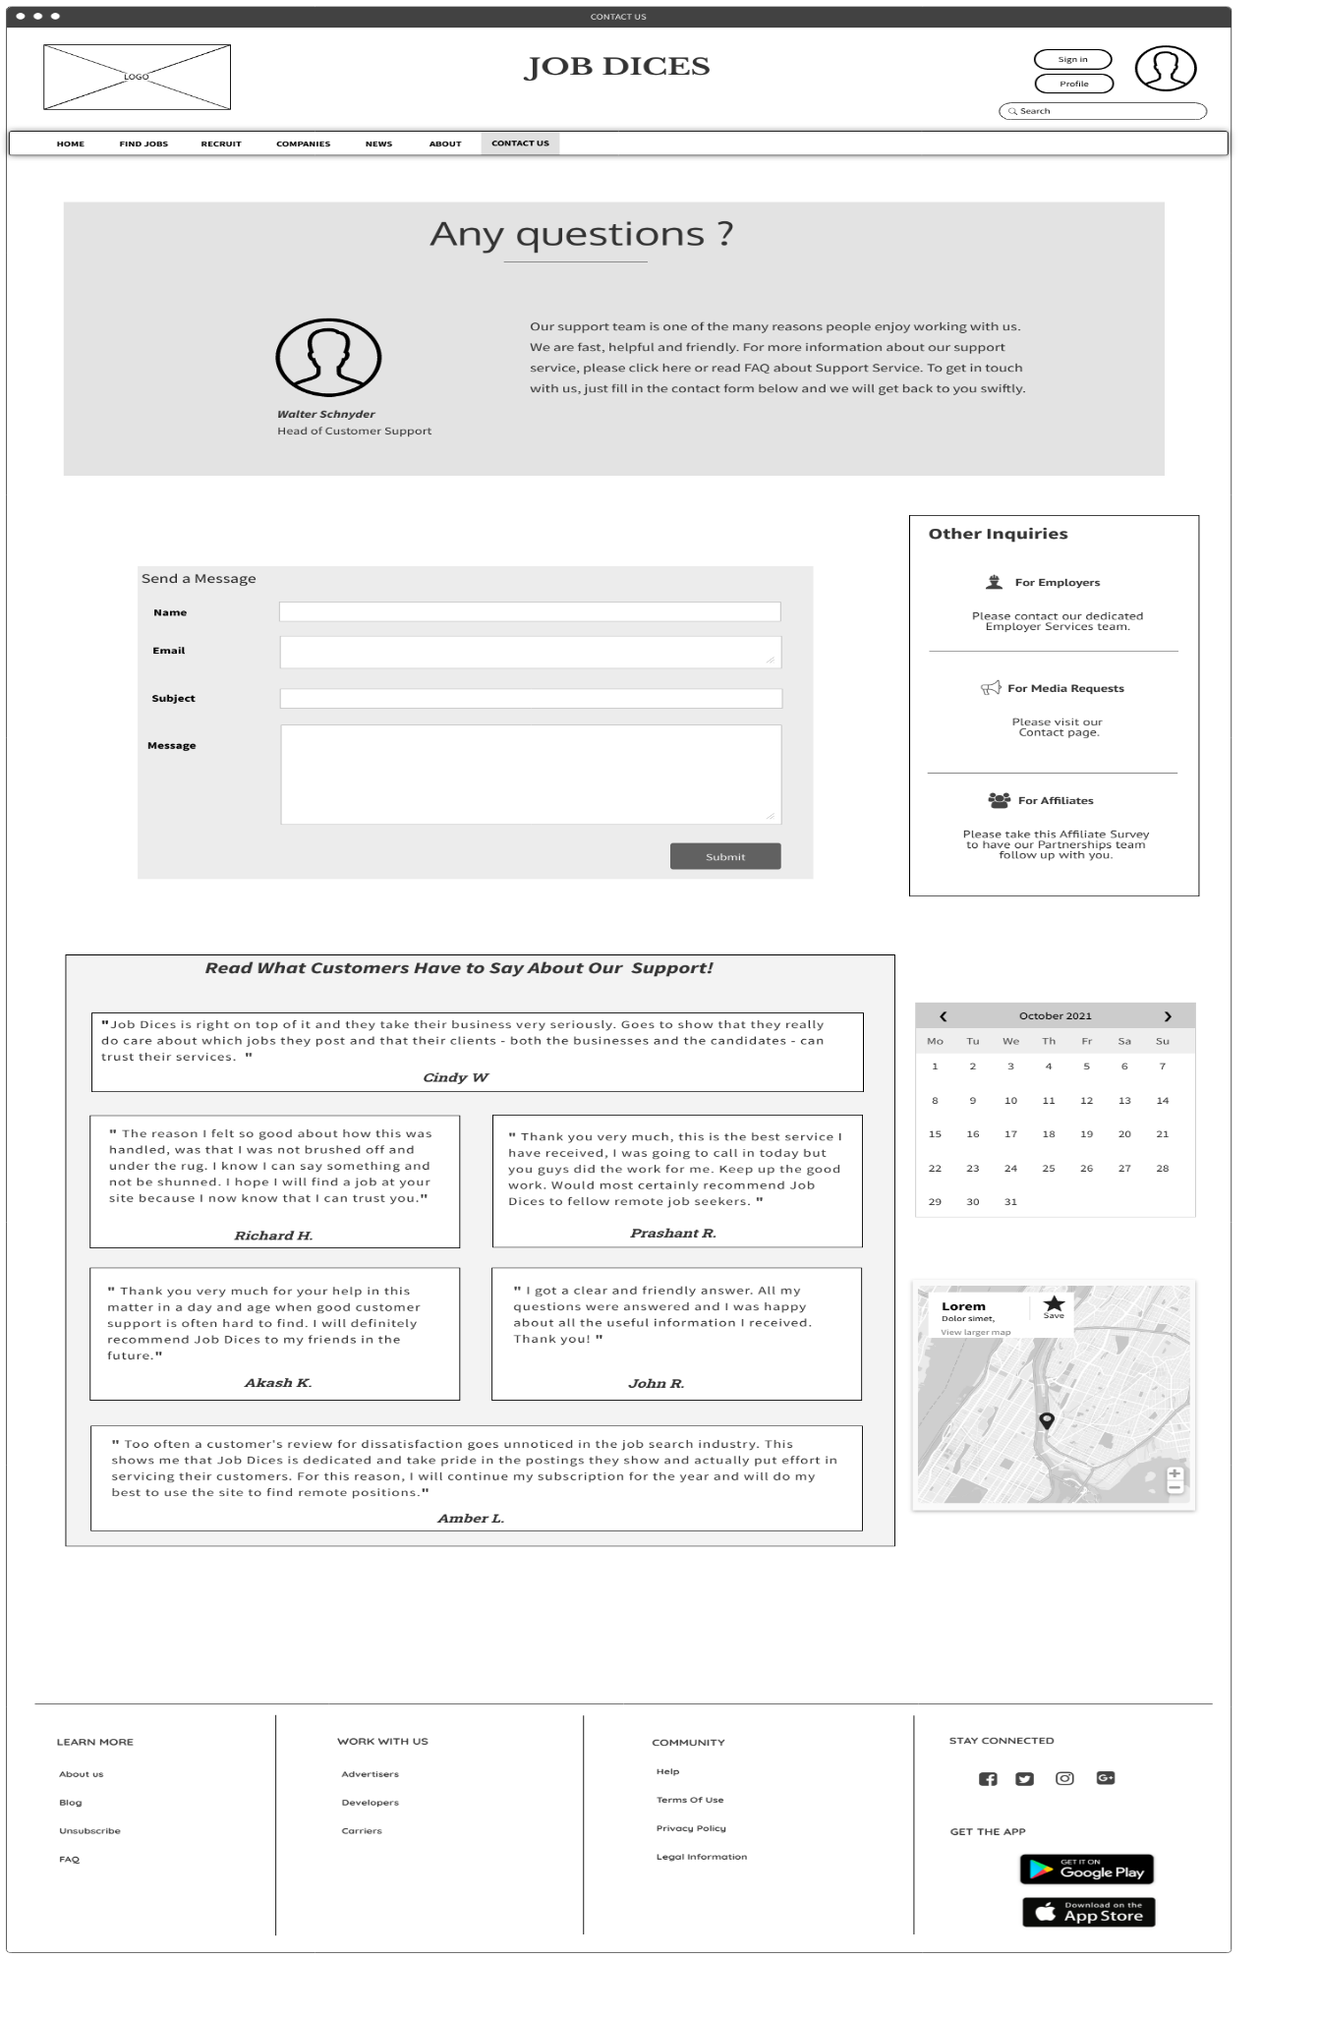

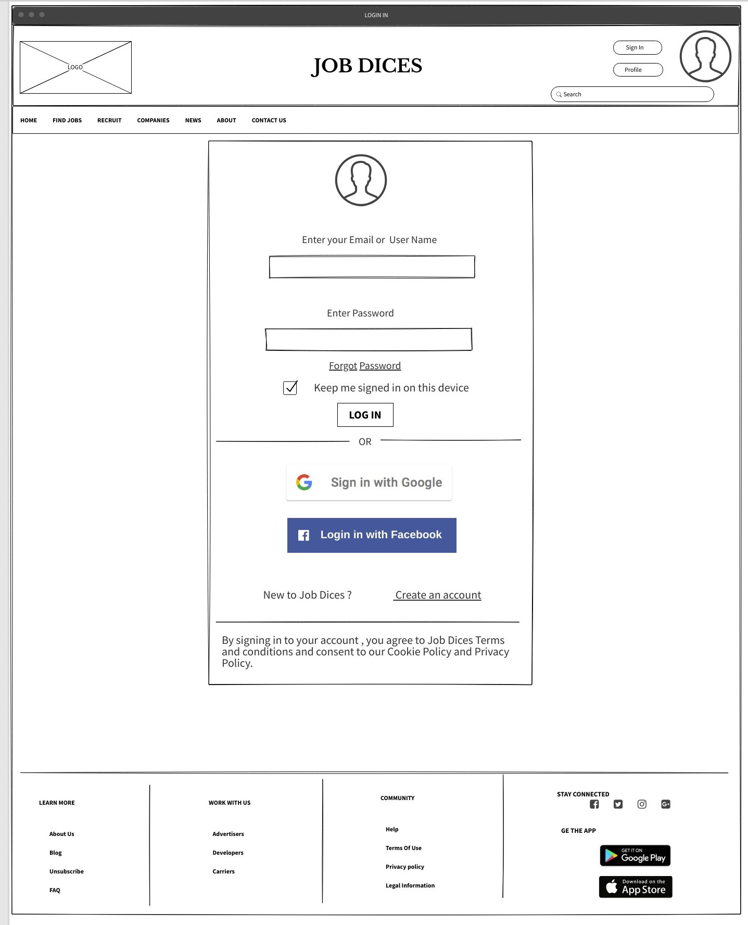

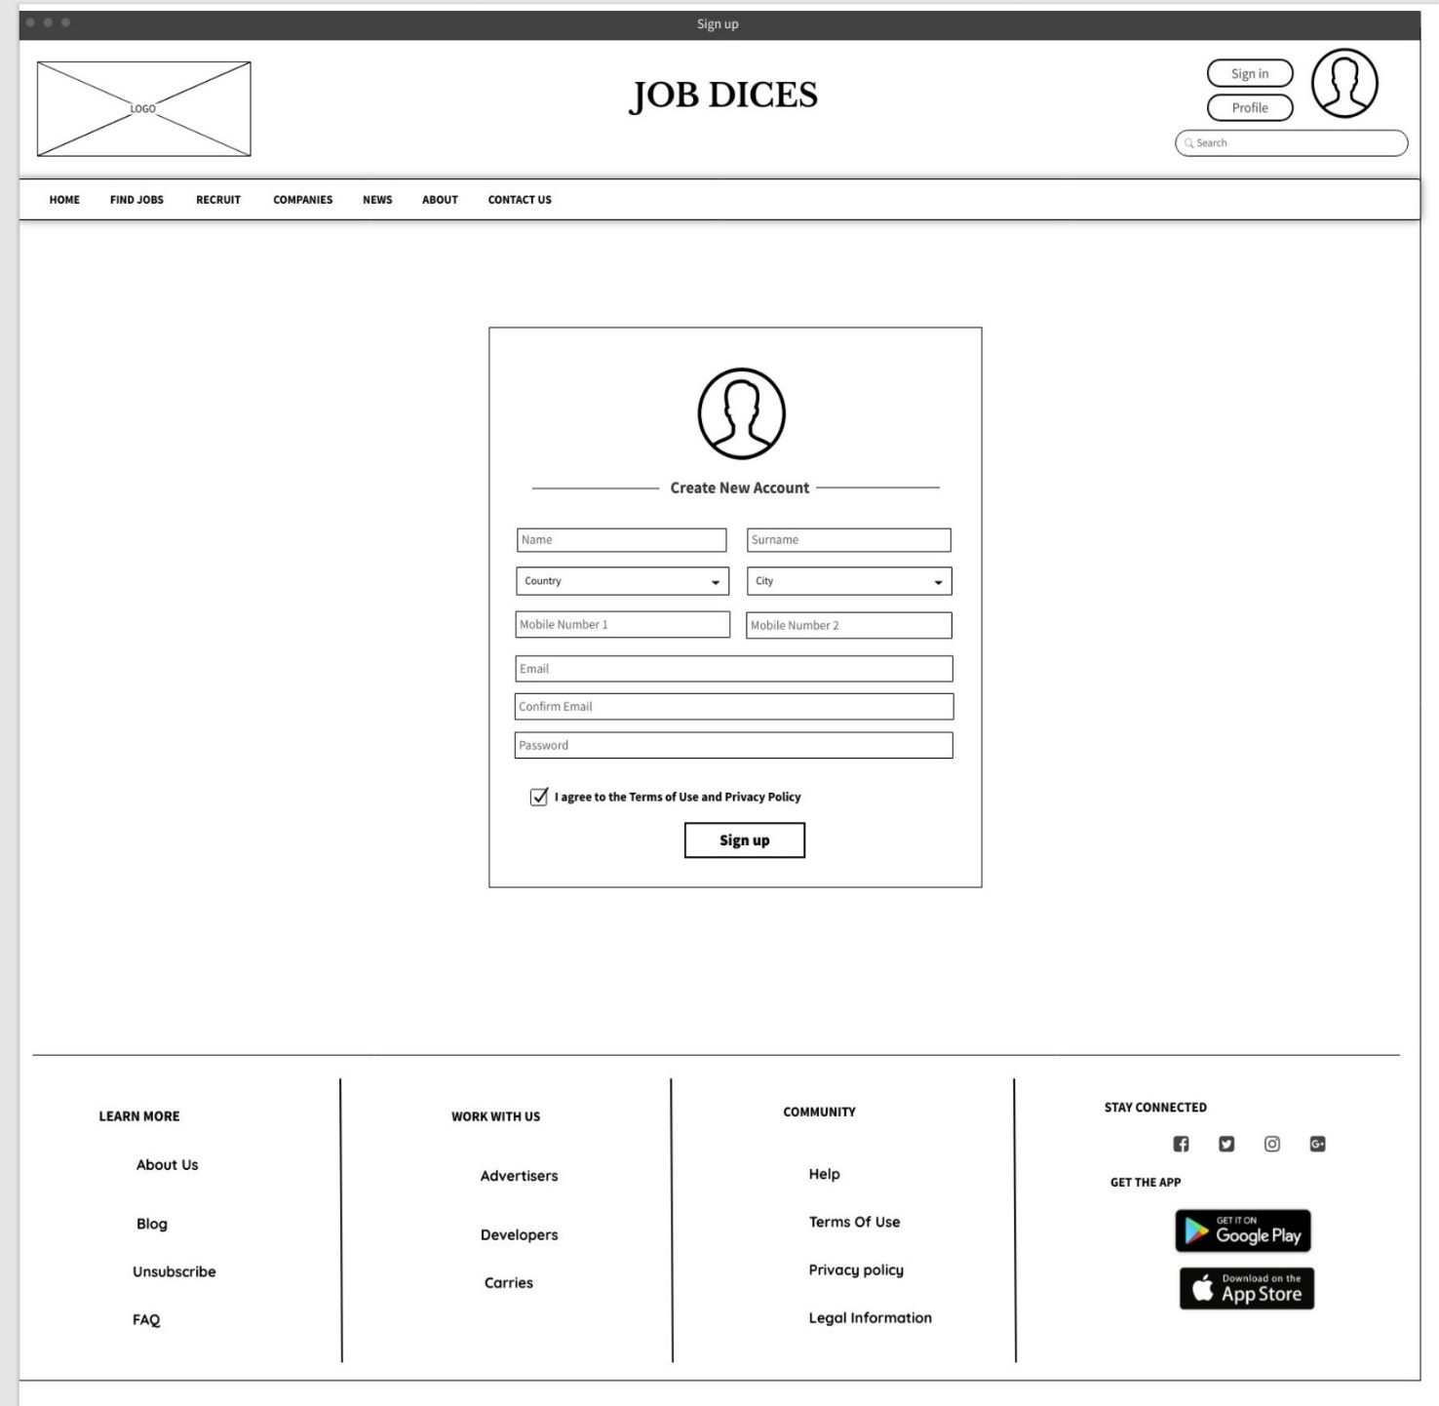

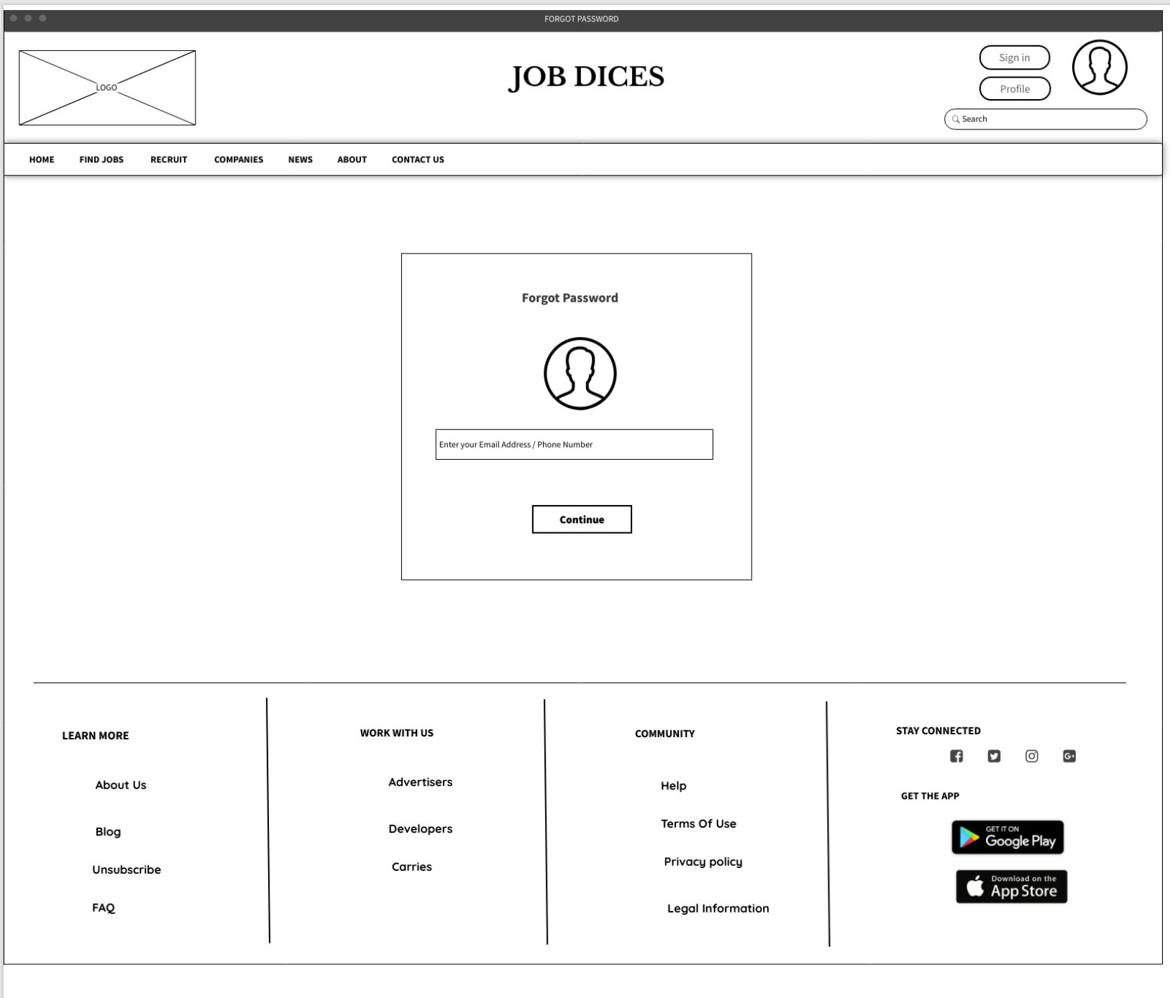

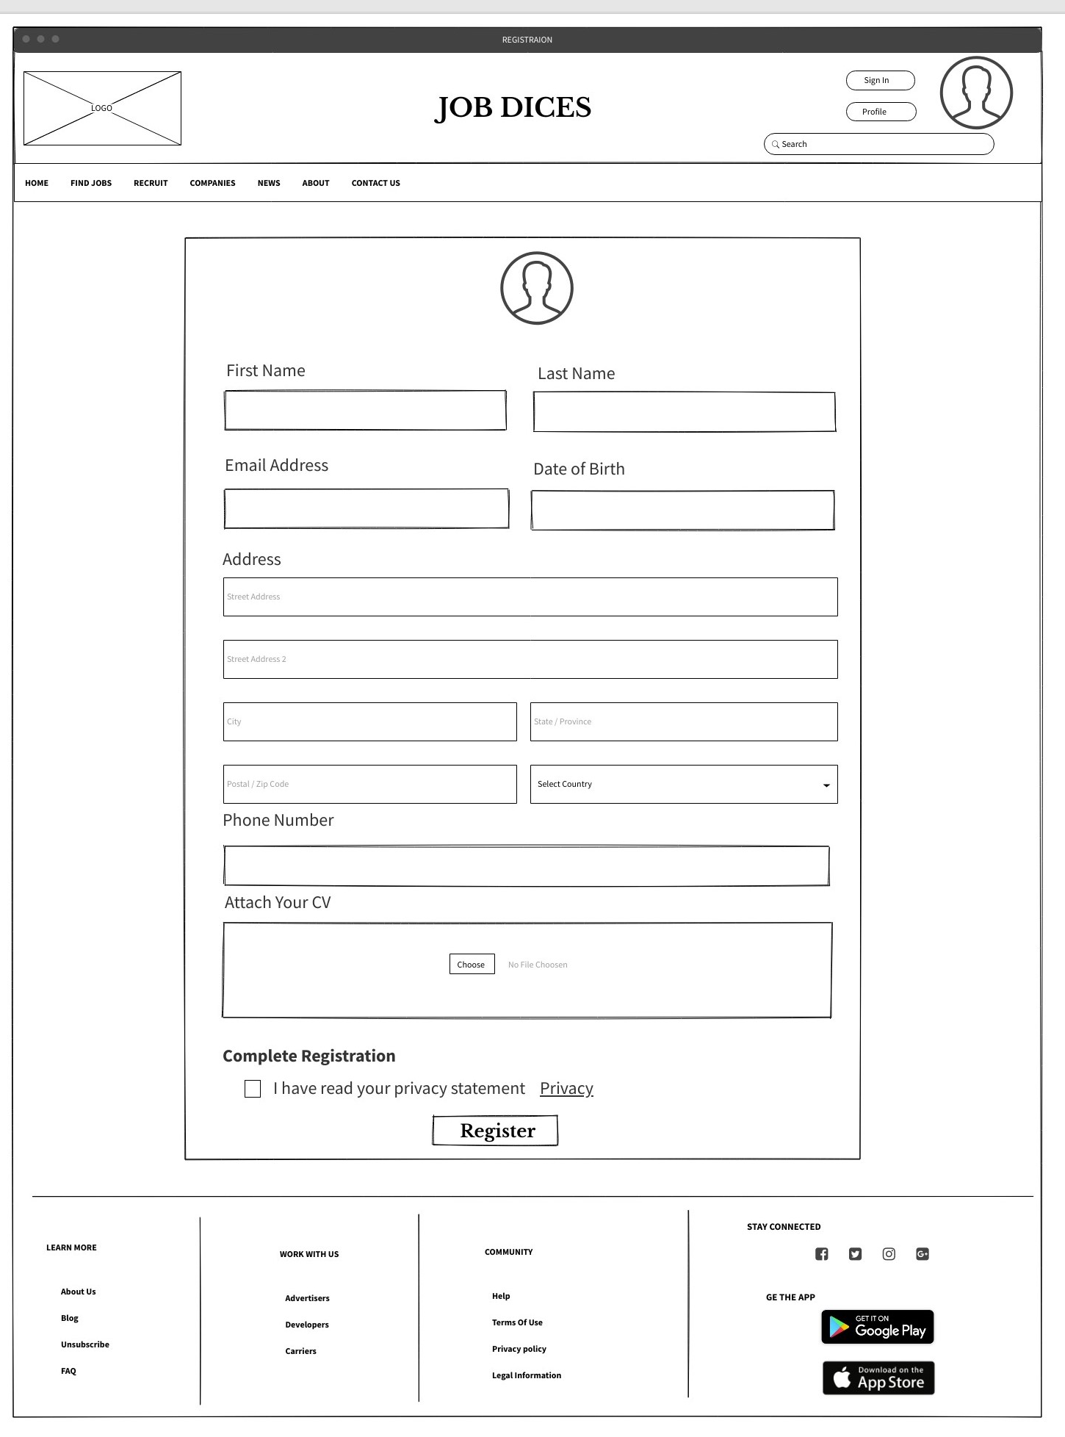

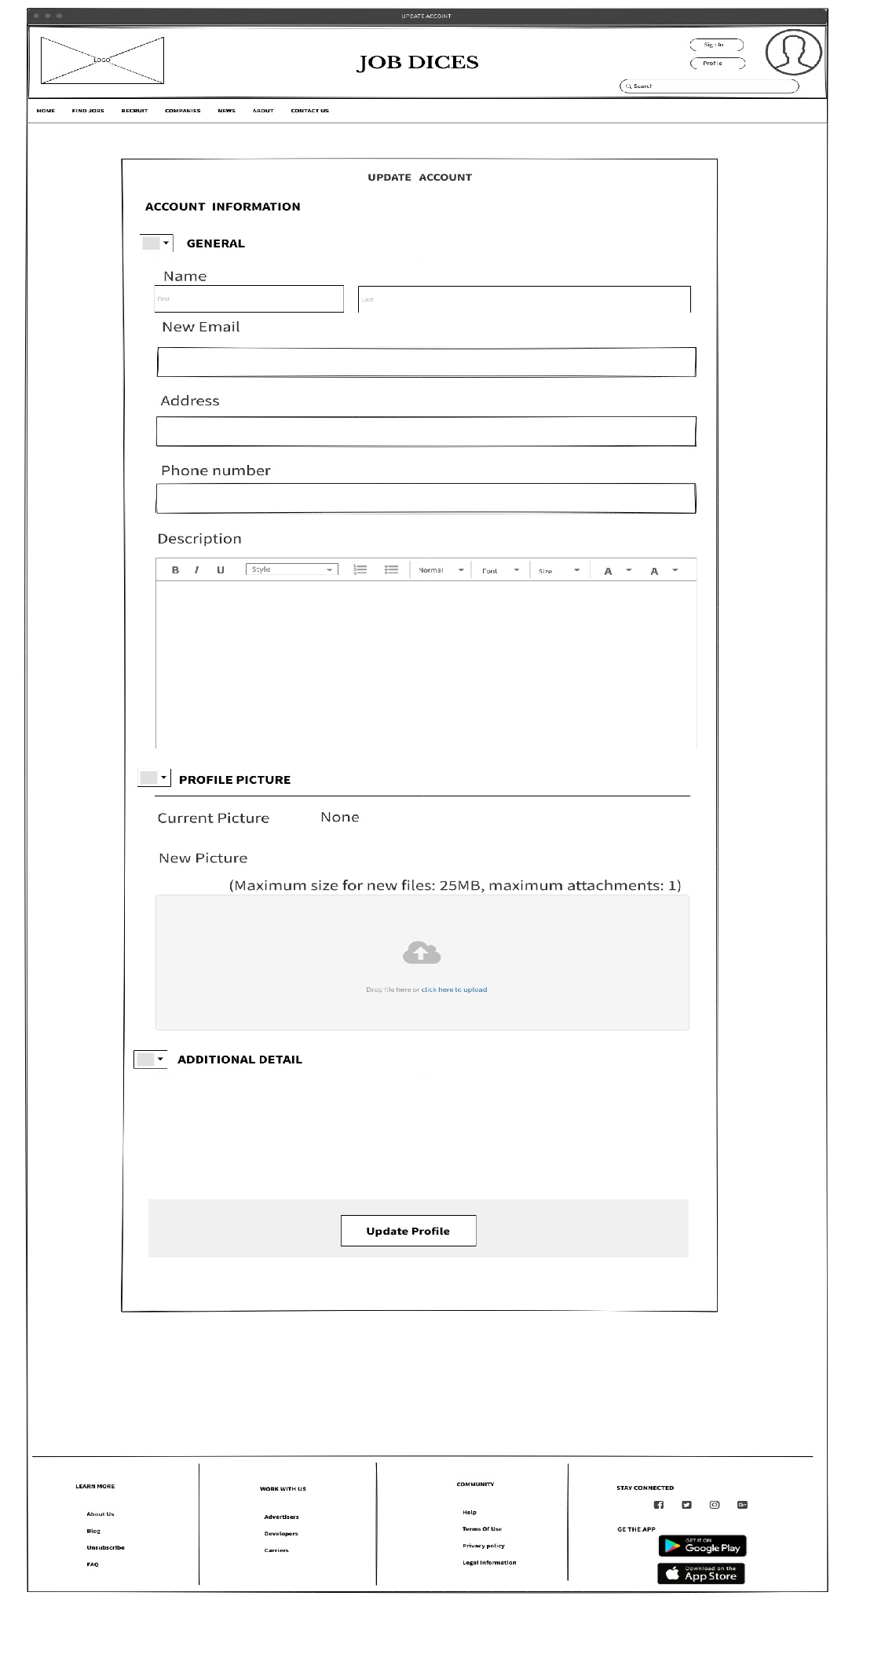

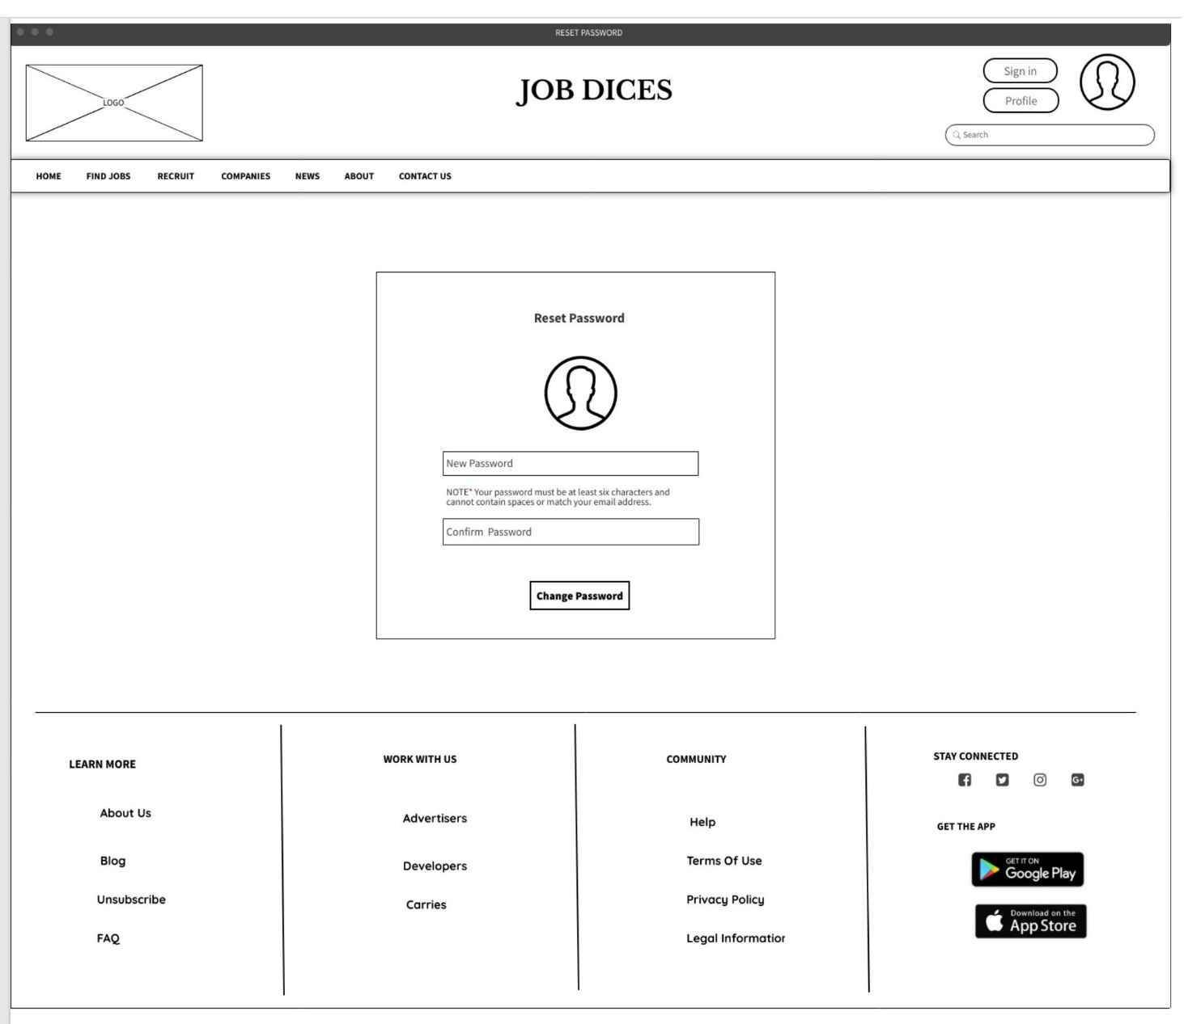

Individual Contribution :-

|  |  |  |  |
| --- | --- | --- | --- |
|  | Student ID | Student Name | Individual Contribution |
| 1 | it21035258 | De Silva S.P.A | * Persona 1 * User Journey 1   Wireframes :   * Companies -pg. 23 * Contact Us -pg.26 |
| 2 | it21039904 | Dayawansa S.D | * Persona 2 * User Journey 2   Wireframes :   * Home - pg.14 * Find Jobs - pg.15 * Banking - pg.16 * Computing - pg.17 * Engineering - pg.18 * Education - pg.19 * Health care - pg.20 * Marketing - pg.21 * News - pg.24 |
| 3 | it21119330 | Obeyesekere S.S | * Persona 3 * User Journey 3   Wireframes :   * Recruit – pg.22 * About – pg.25 |
| 4 | it21062506 | Dissanayake D.M.T.K | * Persona 4 * User Journey 4   Wireframes :   * Login -pg.27 * Registration - pg.30 * Update Account -pg.31 |
| 5 | it21097188 | Arambawela J S | * Persona 5 * User Journey 5   Wireframes :   * Sign up - pg.28 * Forgot password -pg.29 * Reset password- pg.32 |

Group Details :-

|  |  |  |
| --- | --- | --- |
| Student ID | Student Name | Email |
| it21035258 | De Silva S.P.A | it21035258@my.sliit.lk |
| it21039904 | Dayawansa S.D | it21039904@my.sliit.lk |
| it21119330 | Obeyesekere S.S | it21119330@my.sliit.lk |
| it21062506 | Dissanayake D.M.T.K | it21062506@my.sliit.lk |
| it21097188 | Arambawela J S | it21097188@my.sliit.lk |